MODUL
PENGABDIAN KEPADA MASYARAKAT
SKEMA PENGABDIAN KEPADA MASYARAKAT MANDIRI



Pelatihan Menulis Email Menggunakan Bahasa Inggris untuk Remaja di RW 04 Kelurahan Kunciran, Kota Tangerang

Oleh:
Fitri Apriyanti, M.Pd. (0305049202)
Fitriyeni, M.Pd (0312088201)
Hardani, S.Pd, M.M (0308057905)
Yenni Arif Rahman, S.S, M.Pd (0314087903)
Adela Puspita (64241115)
Aditya Ramadhan (64241611)

UNIVERSITAS BINA SARANA INFORMATIKA
FEBRUARI 2026

Pengertian Email

Email adalah singkatan dari "electronic mail" atau "surat elektronik", yaitu metode pengiriman pesan melalui jaringan komputer, terutama internet. Email memungkinkan pengiriman dan penerimaan pesan dalam berbagai format seperti teks, gambar, dan file, dengan cepat dan efisien. Dosen dan mahasiswa dari program studi manajemen sebagai pelaksana PKM ini akan memberikan pelatihan penulisan email dalam bahasa inggris dengan memfokuskan pada bagaimana cara menulis email dengan bahasa inggris dengan baik. Ada banyak cara yang dapat digunakan untuk dapat mengetahui bagaimana cara menulis email dengan bahasa inggris dengan baik, salah satunya dengan mengikuti pelatihan mengenai penulisan email.
(1) E-mail ditemukan pertama kali oleh Ray Tomlinson pada tahun 1972 yang dilatarbelakangi masalah pengiriman pesan dalam internetworkingsaat itu dinilai rumit karena harus memasukkan pesan ke dalam amplop dan memberi alamat yang memerlukan alat penunjuk tujuan surat persis seperti pengiriman surat secara tradisional. Berdasarkan situasi tersebut maka ia menciptakan simbol penulisan e-mail menggunakan format nama-pengguna@alat-komputer. email dalam melakukan surat menyurat dirasakan dan dipikirkan lebih praktis karena tidak menggunakan media alat tulis. Layanan surat elektronik sendiri terbagi ke dalam dua bagian layanan surat elektronik bebas (free) dan layanan surat elektronik terbatas. (2)
Kemampuan untuk menulis email dengan baik sangat bermanfaat dalam kehidupan sehari-hari. Bagi siswa, diperlukan juga kemampuan menulis email dalam bahasa inggris yang baik untuk mengasah kemampuan. Pengertian menulis menurut (3) memang merupakan kegiatan yang melibatkan aktivitas kognitif yang kompleks sehingga tidak satu orang pun mampu menulis jika tidak belajar dan berlatih.

Pengertian Menulis

Menulis tidak sekadar berhubungan dengan tata bahasa dan retorika menulis, tetapi banyak keterampilan dan komponen bahasa lainnya yang dilibatkan. Menurut (4), terdapat 5 aspek yang wajib diperhatikan dalam menulis, diantaranya i) penggunaan bahasa (language use) yakni kemampuan menulis kalimat yang tepat dan benar; ii) mekanisme menulis (mechanical skills) yakni kemampuan menggunakan mekanisme menulis yang baik seperti tanda baca dan ejaan yang benar (punctuation dan spelling) ; iii) penyajian konten (treatment of content) yakni kemampuan untuk berfikir kreatif dalam menyajikan informasi serta kemampuan mengembangkan pemikiran dalam bentuk tulisan; iv) penggunaan gaya bahasa (stylistic skills) yaitu mengembangkan kalimat atau paragraf dan menggunakan bahasa secara efektif; v) keterampilan menilai (judgement skills) merupakan kemampuan menulis dengan sikap yang baik dengan menimbang target pembaca dari tulisan tersebut. Kemampuan menilai ini juga termasuk kemampuan untuk memilih dan menyusun informasi ke dalam bentuk tulisan.
Pemelajar seringkali mengalami kesulitan menulis yang serius dalam hal tata bahasa, kohesi, dan koherensi. Selain itu, mereka juga mengalami kesulitan dalam hal urutan paragraph dan kosakata. Kesulitan tersebut berkaitan dengan perbedaan linguistik dan budaya antara target dan bahasa asli pemelajar dan konteks pengajaran. (5)

  - How to Write a Good Email in English?

Learn the structure of a formal and informal email
Formal emails are professional and used for official or important communications, like contacting clients or managers, while informal emails are casual and friendly, used for personal messages to friends, family, or close colleagues. Formal emails require a clear subject line, professional salutation (e.g., "Dear Ms. Smith"), proper grammar, and a formal closing (e.g., "Sincerely"). Informal emails use casual language, contractions, and greetings like "Hi [First Name]" or "Hey," and can have friendly closings like "Cheers" or "Thanks".
Feature | Formal Email | Informal Email
Purpose | Professional, official, or important matters; job applications, client communication, formal complaints | Casual and friendly communication; personal messages, social invitations, quick updates to friends or close colleagues
Audience | Professionals, clients, managers, people you don't know well | Friends, family, close colleagues, long-term business partners
Tone | Professional, polite, respectful | Casual, relaxed, conversational
Language | Full words, proper grammar, no contractions, no colloquialisms | Casual terms, contractions, colloquialisms, abbreviations, emojis are acceptable
Subject Line | Clear and specific, e.g., "Meeting Request: Q3 Financial Review" | Can be more casual, e.g., "Quick question!"
Salutation | "Dear Mr./Ms. [Last Name]," "Dear Sir/Madam," | "Hi [First Name]," "Hello [First Name]," "Hey,"
Closing | "Sincerely," "Best regards," "Kind | "Cheers," "Best," "Thanks," "Talk soon,"

Use correct tone and vocabulary
For professional emails, the correct tone and vocabulary depend on the relationship with the recipient and the context of the message. Your tone can range from formal to friendly, and the key is to be polite, clear, and respectful in every situation.
Choosing the right tone and vocabulary
Know your audience
The relationship you have with the recipient is the most important factor in determining your email's tone.
- For managers or clients: Use a more formal and respectful tone. Your vocabulary should be precise and professional, avoiding slang or overly casual expressions.
- For close colleagues: A more casual or conversational tone is acceptable, but still remain professional. Some informal phrases might be fine, depending on your workplace culture.
- For new contacts: When writing to someone for the first time, such as in a job application or with a new client, err on the side of formality to make a strong, professional first impression.
Match the context
The purpose of your email should also influence your tone.
- Routine communication: A standard, professional tone is appropriate for everyday updates.
- Negative news or difficult situations: Stay polite and positive. Frame language constructively rather than using blameful or negative words.
- Congratulatory message: A more enthusiastic and informal tone can be used for good news, like congratulating a team on a success.

Practice writing clear and effective emails
How to write clear and effective emails
To write effective emails, you should practice using clear, concise, and professional language. A well-structured email with a specific subject line, polite tone, and call to action is more likely to be read and acted upon. Practicing with different scenarios can help you master the key elements of email communication.
1. Master the subject line
The subject line is the first thing recipients see, so it must be specific and informative. Avoid vague subject lines like "Following up" and use descriptive phrases instead.
Example:
- Vague: Meeting
- Effective: Agenda for Monday's team meeting
- Vague: Quick question
- Effective: Clarification needed: Budget proposal draft
2. Focus and structure your message
Get to the main point of your email quickly. Use short paragraphs, bullet points, or numbered lists to make the information easy to scan and digest. If you must address multiple topics, consider sending separate emails for each.
Example:
- Ineffective (long block of text): I'm writing about the new project. There are several things to discuss. First, we need to decide on the budget, and then we need to set the timeline. Also, we need to assign tasks to the team members. And finally, we need to schedule a meeting to go over all these points.

- Effective (using a list):
- I'm writing to outline the next steps for the new project.
  - Confirm the budget
  - Finalize the timeline
  - Assign team tasks
  - Schedule a meeting to discuss these points
3. Proofread carefully
An email with errors can be a distraction and appear unprofessional. Always proofread for spelling, grammar, and punctuation mistakes before sending. Reading your email aloud can help you catch awkward phrasing.
Example:
- Email draft: "Hi team, just wanted to send a quick reminder about the report that's due tomorrow. Let me know if you need anything else."
- Proofread and revised: "Hi Team, just a quick reminder that the report is due tomorrow. Please let me know if you need anything."
4. Practice scenarios
You can practice these tips by writing emails for common workplace situations.
Scenario 1: Replying to a client's request
Instructions: Your client, Mr. Jones, asked for a progress update on a project. Write a polite and concise email informing him of the status.
Email template:
- Subject: Project X Progress Update
- Greeting: Dear Mr. Jones,
- Body: Thank you for reaching out. The team is making good progress on Project X. We have completed the first milestone and are on track to finish on schedule. We will send you a detailed report on Friday.
- Closing: Best regards, [Your Name]
Scenario 2: Scheduling a meeting
Instructions: You need to schedule a meeting with your colleagues, John and Sarah, to discuss the budget. Write an email to find a suitable time.
Email template:
- Subject: Meeting to discuss the Q4 budget
- Greeting: Hi John and Sarah,
- Body: I'd like to schedule a meeting to discuss the Q4 budget. Please let me know which of these times works for you:
  - Tuesday at 10:00 a.m.
  - Wednesday at 2:00 p.m.
  - Thursday at 11:00 a.m.
- Closing: Thanks, [Your Name]
Scenario 3: Requesting a day off
Instructions: You need to request a day off for a personal appointment. Write a formal email to your manager, Ms. Davies.
Email template:
- Subject: Leave Request: [Date]
- Greeting: Dear Ms. Davies,
- Body: I am writing to formally request a day of leave on [Date] for a personal appointment. I have completed all urgent tasks and have prepared [Colleague's Name] to handle my duties while I am away. I will check my email periodically.
- Closing: Thank you for your consideration,
[Your Name]

  - When Do We Use Emails?
- To contact teachers or principals
You use email to contact teachers or principals for scheduling meetings, asking questions, or communicating about student progress when a face-to-face or phone conversation isn't immediately possible. It's a good method for non-urgent, detailed, or time-sensitive matters, and is often preferred for a documented trail of communication. For complex or urgent issues, it's often better to request a phone call or in-person meeting.
When to email teachers or principals
- Scheduling and planning:
Send an email to request a meeting to discuss a student's progress or a specific issue.
- Documenting communication:
When you need to create a record of a conversation, like a request for an extension or a question about an assignment.
- When they are hard to reach:
Email is useful for contacting teachers or principals who have busy schedules, work in different locations, or are not available by phone.
- For non-urgent questions:
Ask questions that don't require an immediate answer. For example, you could ask about homework, upcoming events, or class policies.
When to consider other methods
- For complex issues:
A phone call or in-person meeting is better for discussing complex or sensitive topics, as it allows for a more immediate back-and-forth.
- For urgent matters:
If the issue is urgent, call the school or the teacher directly. Email is not a reliable method for urgent requests because responses are not always immediate.
- To avoid misunderstandings:
Complex or sensitive topics can be easily misunderstood over email, making a direct conversation a better option.

- To apply for scholarships
You use email to apply for scholarships by sending the application, asking for recommendations, and communicating with the program. Emails are crucial for submitting your application materials, receiving updates on your status, and following up on the process.
When to use email
- To submit applications:
Some scholarships require you to email your application materials directly.
- To request letters of recommendation:
You should email potential recommenders to ask for their support, giving them advance notice and information they'll need to write a strong letter.
- To correspond with the scholarship provider:
It is common to use email for all communication with the scholarship organization, including asking clarifying questions about the application process.
- To follow up after applying:
You will receive important updates, reminders, and decisions via email after you have submitted your application.
How to use email effectively
- Create a professional email address:
Use a new, professional-sounding email address for scholarship applications so it's easy to track and keeps your personal inbox clean.
- Use a clear and professional format:
Structure your emails logically, use a professional font, and include a signature with your full name and contact information.
- Be specific and concise:
When asking questions, be brief and to the point. Make sure the answer isn't readily available on the organization's website.
- Address it to a specific person:
Whenever possible, find and use a specific contact person's name to address your email, spelling it correctly.

- To write to friends or family
You use email to write to friends or family for informal communication, such as sending updates, catching up, or sending reminders for events. These messages can be casual, conversational, and may not require an immediate response, unlike text messages or calls.
- Informal tone:
You can use casual language, slang, and greetings like "Hey!" because you are writing to someone you know well.
- Flexibility:
Email allows for longer, more detailed messages than a text, but you can still keep it short and quick. It also gives you time to think and edit your message before sending.
- Purpose:
You might use it to share news, ask questions about their life, or organize something that doesn't require an instant reply.

  - Email Structure Overview
- Subject Line
A subject line is what the reader sees in their inbox. It should be short and easy to understand. Try to use seven words or less to summarize the purpose of the email.
- Greeting
Choose a professional greeting, also called a salutation, to start with a strong impression. Use the recipient’s professional name or title if you don’t know them. Do not assume their preferred pronouns, such as Mr., Mrs. or Ms.
- Opening Sentence
There is no standard formal email opening, so you’ll have to decide what’s appropriate for the communication and its context. If you don’t know the person, it’s polite to introduce yourself in the opening lines.
- Body
The body of a formal email typically explains the purpose of the email. Be respectful of the recipient’s time, so keep the body as direct and brief as possible. When possible, include just one or two short paragraphs. When reaching out to a new contact with a pitch requiring more substantial information, include it as an attachment instead or offer to reach out with more information if the recipient is interested.
- Closing Sentence
As with the address, you should include a formal closing. Since the closing is the last thing the recipient looks at, you want it to leave a lasting impression.
- Sign-off
Sign off with your name and professional title. If you have an email account with a preset signature, ensure that the information contained is professional in tone. Include details, such as email address and phone number, so that the recipient can respond to you.

IV. Example of Formal Email

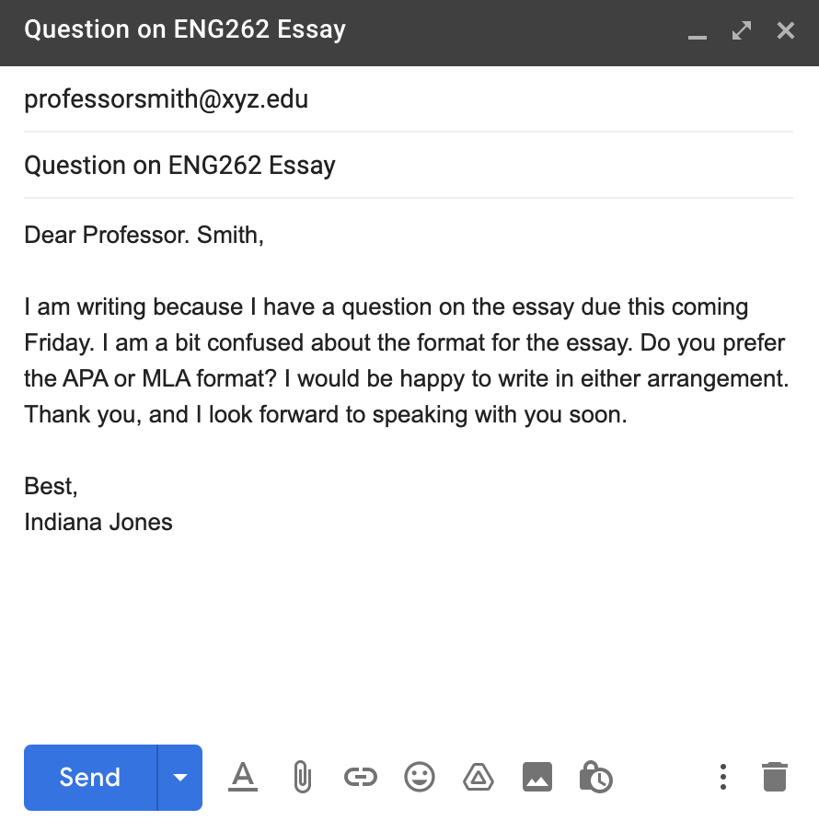

V. Example of Informal Email

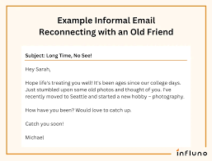

Do’s and Don’ts (Formal)
- Do:
- ✅ Use proper punctuation
- ✅ Be polite and respectful
- Don't:
- ❌ Use emojis
- ❌ Use slang
Do’s and Don’ts (Formal)
- ` Do:
- ✅ You can use emojis 😃
- ✅ Keep it fun but clear
- Don't:
- ❌ Be rude

VI. Common Mistakes in Writing Email
Common email mistakes include poor subject lines, a lack of proofreading for grammar and spelling errors, and incorrect use of recipients (like hitting "Reply All" by accident). Other mistakes involve unprofessional tone, being overly long or vague, forgetting attachments, and using generic or overly casual greetings and closings.
Content and formatting
- Vague or missing subject line: A clear subject line is crucial for the recipient to understand the email's purpose. Leaving it blank or using a generic title like "Hello" is a common mistake.
- Lack of proofreading: Typos, grammatical errors, and poor punctuation can damage your professionalism.
- Writing in all caps: This is widely perceived as shouting and can come across as rude.
- Excessive length: Long, rambling emails are hard to read and are often not fully read.
- Incorrect tone: Using a tone that is too formal, too informal, or overly emotional can create a negative impression.
- Using emojis or jargon: These can be unprofessional and may not be understood by all recipients.
- Forgetting attachments: Sending an email with a reference to an attachment that is not actually included is a frequent error.
- Unprofessional email address: Having an inappropriate or unprofessional email address can reflect poorly on you.
Recipient and reply management
- "Reply All" errors:
Hitting "Reply All" when the message is only intended for one person is a classic and embarrassing mistake.
- Wrong recipient:
Sending an email to the wrong person, or accidentally adding the wrong person from an autocomplete list, is a serious error.
- Improper use of BCC:
Not using "BCC" when you want to protect the privacy of recipients can expose their email addresses to the entire group.
Salutations and closings
- Generic greetings: Using a generic "To whom it may concern" can seem impersonal and lazy.
- Lack of greeting or closing: Starting or ending an email without a proper salutation or sign-off can be seen as unprofessional.
- Being too familiar or formal: Starting with a very casual tone, or being excessively formal with a contact you know well, can be off-putting.

VII. Useful Vocabularies
- Request
- Inform
- Confirm
- Attach
- Appreciate
- Let me know
- catch up
- hang out

VIII. Tips for Success Sending an Email
To send a successful email, keep your message clear and concise, proofread it carefully, and use a professional subject line. Tailor the content to your audience, include a clear call to action, and double-check the recipient address before sending.
Before you write
- Define your goal: Know what you want to achieve with the email before you start writing.
- Know your audience: Consider who you are writing to and tailor your message accordingly.
- Use a professional address: Use a professional email address, especially for work or important communications.
When writing
- Craft a clear subject line: Make it informative so the recipient knows what the email is about at a glance.
- Get straight to the point: Be direct and keep your message concise, ideally no more than a few sentences.
- Personalize where possible: Use the recipient's name to make the email feel more personal.
- Use formatting for readability: Use bullet points and white space to break up text, especially for longer messages.
- Include a clear call to action (CTA): Tell the reader exactly what you want them to do next and by when.
- Maintain a professional tone: Be collegial and courteous. Avoid emojis or excessive exclamation points.
- Consider attachments: If you have attachments, mention them in the email body and double-check that they are attached.
Before you send
- Proofread thoroughly: Check for spelling, grammar, and punctuation errors.
- Check recipients: Ensure you have entered the correct email address in the "To," "Cc," and "Bcc" fields and that you are not accidentally sending to everyone with "Reply All".
- Reread the email: Take one last look to ensure the message is clear and the call to action is obvious.

10 tips for effective email marketing

1. Provide valuable content
To grab and keep your customers’ attention, your emails need to provide value. Whether it’s informative articles, exclusive promotions, or helpful insights about your product or service, you should aim to deliver content that establishes trust and reinforces your brand’s authority engagingly.
By consistently offering value in your emails, you’ll keep subscribers interested and eager to open future communications, ultimately driving stronger relationships and better results for your cross-channel marketing efforts.

2. Place a call to action early in the email
Most people skim-read emails to see if they offer anything of value. If your content grabs their interest, they’ll be more likely to click on a link or take action. That’s why you need to place your call to action (CTA) near the top of your email.
The alternative—leaving your CTA until later—risks losing the reader’s attention. In the fast-paced digital world, people’s attention spans are short. So, place your CTA within the first sentence or right after the opening paragraph to ensure it gets noticed.

3. Left-align your text
When formatting your emails, you’ll quickly learn that left-aligned text is much easier to read. This is because when you center-align your text, the starting place of each line changes. This forces your readers to work harder to find where each line begins and continue reading. Without a straight left edge, there is no consistent place where users can move their eyes when they complete each line.
So, in the interest of keeping readers switched on to your text, you should make it as readable as possible. This includes its format on screens. With left alignment, users can read each line by simply moving their eyes to the left edge each time, making your paragraphs faster and easier to read.

4. Include links throughout your email
While placing a link at the start of your email is a good strategy, you should also incorporate links throughout the email to encourage more click-throughs. Whether it’s in the body content, an image, or a ‘Find Out More’ button—use clear and enticing links that guide recipients toward engagement.

5. Add alternate text to your images
Alternate or ‘alt’ text can ensure maximum accessibility and improve the user experience of your emails. This is a short description of an image’s content that can be interpreted by a screen reader or displayed in the email itself when an email client doesn’t automatically download images.
By adding alt text to all of your imagery, you’re able to get your message across to the email recipient even if they can’t see the image, which is growing increasingly common as a security measure against malicious email content. In instances when your emails rely heavily on images, alt tags are a useful tool.

6. Add preview text (a Super Subject Line)
Preview text, or the preheader, is the snippet of text that appears after the email subject line in most email programs. Think of it as your second chance to grab attention if the subject line didn’t do the trick. This short bit of copy can give readers another compelling reason to open the email or follow one of its CTAs.

7. Be descriptive and concise
Once you’ve written the content to be included in your marketing emails, it’s vital that you don’t use the standard ‘read more’ or ‘buy now’ CTAs. Instead, they need to be transactional. The recipient must know what they’re reading more of and what will happen to them once they’ve made that click.
And when it comes to the language you use, the more concise the better. If users have to scroll to read the entire email, then make it a landing page or a web page instead. Readability is crucial, so while you need to clearly inform readers of your message, you shouldn’t ever include more content than necessary just for the sake of it.

8. If you’re sending out a prospect email, send it from the CEO
Boost the success of your prospect emails by sending them from the CEO. Even if the CEO didn’t write the email, their name adds credibility and makes it more likely that the recipient will engage or respond.
Many companies fall into the trap of sending sales emails from the Managing Director — as usually, they’re the person who has approved the email. But as fewer people will know who the MD is for the company, it’s a better strategy to send from CEO and include the company name.

9. Provide standard blue hyperlinks
Any links you insert in the text of your email should follow the classic hyperlink format — blue, underlined, clickable. Unless you’re using a compelling CTA button. This makes it easy for recipients to spot links while they’re skimming through your email.
If you’re using branded links, be careful. Recipients may be wary of clicking on unfamiliar branded links if they don’t clearly indicate the destination, leading to lower click-through rates. If you’re reaching out to a customer who could be unfamiliar with your brand, stick to conventional hyperlink tactics.

10. Distribute your email with a mailing list
One of the most effective ways to circulate your message is to use a mailing list. This is a collection of email addresses used to distribute marketing emails to subscribers who have opted in to receiving communications.
Using a mailing list offers a host of benefits, delivering higher traffic and rates of conversion.

Reflection Questions
- What makes a good email?
- When should I use formal or informal style?

Writing Activity
Task: Write a formal email to your English teacher asking about an assignment!

