TUTORIAL IMPLEMENTASI DATABASE
Sistim Informasi Proyek
(Simpro)

Oleh:
- Bambang Junadi M.kom
- Handini Widyastuti M.kom
- Khairul Rizald M.Kom
- Sri Utami M.kom
- Syamsudin S.Pd.I,M.Pd
- Yuni Fitriani,S.T,M.M
- Andi Diah Kuswanto M.Kom

April 2026

Pendahuluan.
Design atau skema basis data ini merupakan bagian dari aplikasi Sistim Informasi Proyek (Simpro). Aplikasi ini (simpro) digunakan pada proyek-proyek civil. Design database Simpro di design untuk menggunakan Database Management System (DBMS) MySQL.

Cara Instalasi /Implementasi
- Aktifkan MySQL
- Login ke MySQL (sebagai root)
- Buat /Create Database db_simpro.
- Aktifkan (use) Database baru tersebut
- Jalankan Sql dari skema/design database dibawah ini

Structure Query Language (SQL) db_simpro
CREATE TABLE biaya_proyek
(
id_biaya integer AUTO_INCREMENT,
id_proyek integer NULL,
tgl_buat date NULL,
kategori VARCHAR(1) NULL,
nama_biaya text(65535) NULL,
jumlah decimal(15,2) NULL,
satuan CHAR(5) NULL,
PRIMARY KEY (id_biaya )
);

CREATE TABLE gambar_proyek
(
id_gambar integer AUTO_INCREMENT,
id_proyek integer NULL,
nama_gambar varchar(200) NULL,
keterangan text(65535) NULL,
file_path varchar(255) NULL,
tanggal_upload date NULL,
id_user integer NULL,
PRIMARY KEY (id_gambar)
);

CREATE TABLE pekerjaan_progress
(
id_progress integer AUTO_INCREMENT,
id_proyek integer NULL,
tgl_progress date NULL,
deskripsi text(65535) NULL,
persentase_progress decimal(5,2) NULL,
id_user integer NULL,
PRIMARY KEY (id_progress)

);

CREATE TABLE penerimaan_barang
(
id_penerimaan integer AUTO_INCREMENT,
tanggal date NULL,
nama_barang varchar(200) NULL,
jumlah integer NULL,
satuan varchar(50) NULL,
penerima integer NULL,
id_po INTEGER NULL,
id_supplier INTEGER NULL,
PRIMARY KEY (id_penerimaan)
);

CREATE TABLE pimpro
(
id_primpro INTEGER AUTO_INCREMENT,
nama_pimpro CHAR(30) NULL,
alamat_pimpro CHAR(100) NULL,
nohp_pimpro CHAR(13) NULL,
email_pimpro CHAR(30) NULL,
PRIMARY KEY (id_primpro)
);

CREATE TABLE proyek
( id_proyek integer AUTO_INCREMENT,
nama_proyek varchar(200) NULL,
lokasi varchar(200) NULL,
tanggal_mulai date NULL,
tanggal_selesai date NULL,
id_primpro INTEGER NULL,
PRIMARY KEY (id_proyek));

CREATE TABLE rapat
(
id_rapat integer AUTO_INCREMENT,
id_proyek integer NULL,
tgl_rapat date NULL,
agenda varchar(200) NULL,
notulen text(65535) NULL,
id_peserta INTEGER NULL,
id_user integer NULL,
PRIMARY KEY (id_rapat)
);

CREATE TABLE surat_keluar
(
id_surat integer AUTO_INCREMENT,
id_proyek integer NULL,
no_surat varchar(100) NULL,
tgl_srt_klr date NULL,
jenis char(6) NULL,
perihal varchar(200) NULL,
dari_kepada varchar(200) NULL,
file_path varchar(255) NULL,
id_user integer NULL,
PRIMARY KEY (id_surat)

);

CREATE TABLE surat_masuk
(
id_surat integer AUTO_INCREMENT,
id_proyek integer NULL,
no_surat VARCHAR(20) NULL,
tgl_srt_msk date NULL,
jenis char(6) NULL,
perihal varchar(200) NULL,
dari_kepada varchar(200) NULL,
file_path varchar(255) NULL,
id_user integer NULL,
PRIMARY KEY (id_surat)
);

CREATE TABLE tbl_peserta_rapat
(
id_peserta INTEGER NOT NULL,
nama_peserta CHAR(30) NULL,
no_hp_peserta char(13),
email_peserta char(30),
PRIMARY KEY (id_peserta)
);

CREATE TABLE tbl_po
(
id_po INTEGER NOT NULL,
tgl_po DATE NULL,
keterangan_po CHAR(100) NULL,
id_supplier INTEGER NOT NULL,
id_proyek integer NULL,
PRIMARY KEY (id_po,id_supplier)
);

CREATE TABLE tbl_po_detail
(
id_po INTEGER NOT NULL,
id_supplier INTEGER NOT NULL,
satuan CHAR(5) NULL,
jumlah DECIMAL(6,2) NULL,
id_biaya integer NULL,
PRIMARY KEY (id_po,id_supplier)
);

CREATE TABLE tbl_supplier
(
id_supplier INTEGER NOT NULL,
nama_supplier CHAR(50) NULL,
alamat CHAR(100) NULL,
no_tlp CHAR(13) NULL,
no_hp CHAR(13) NULL,
kontak_person CHAR(30) NULL,
PRIMARY KEY (id_supplier)
);

CREATE TABLE users
( id_user integer AUTO_INCREMENT,
Password varchar(30),
nama varchar(100) NULL,
jabatan varchar(50) NULL,
email varchar(100) NULL,
no_hp varchar(20) NULL,
role CHAR(10) NULL,
reset_token char(30),
PRIMARY KEY (id_user)
);

ALTER TABLE biaya_proyek
ADD FOREIGN KEY biaya_proyek_ibfk_1 (id_proyek) REFERENCES proyek (id_proyek);

ALTER TABLE gambar_proyek
ADD FOREIGN KEY gambar_proyek_ibfk_1 (id_proyek) REFERENCES proyek (id_proyek);

ALTER TABLE gambar_proyek
ADD FOREIGN KEY R_26 (id_user) REFERENCES user (id_user);

ALTER TABLE pekerjaan_progress
ADD FOREIGN KEY pekerjaan_progress_ibfk_1 (id_proyek) REFERENCES proyek (id_proyek);

ALTER TABLE pekerjaan_progress
ADD FOREIGN KEY R_28 (id_user) REFERENCES user (id_user);

ALTER TABLE penerimaan_barang
ADD FOREIGN KEY penerimaan_barang_ibfk_2 (penerima) REFERENCES user (id_user);

ALTER TABLE penerimaan_barang
ADD FOREIGN KEY R_17 (id_po, id_supplier) REFERENCES tbl_po (id_po, id_supplier);

ALTER TABLE proyek
ADD FOREIGN KEY R_25 (id_primpro) REFERENCES pimpro (id_primpro);

ALTER TABLE rapat
ADD FOREIGN KEY rapat_ibfk_1 (id_proyek) REFERENCES proyek (id_proyek);

ALTER TABLE rapat
ADD FOREIGN KEY R_13 (id_peserta) REFERENCES tbl_peserta_rapat (id_peserta);

ALTER TABLE rapat
ADD FOREIGN KEY R_27 (id_user) REFERENCES user (id_user);

ALTER TABLE surat_keluar
ADD FOREIGN KEY R_14 (id_proyek) REFERENCES proyek (id_proyek);

ALTER TABLE surat_keluar
ADD FOREIGN KEY R_30 (id_user) REFERENCES user (id_user);

ALTER TABLE surat_masuk
ADD FOREIGN KEY surat_ibfk_1 (id_proyek) REFERENCES proyek (id_proyek);

ALTER TABLE surat_masuk
ADD FOREIGN KEY R_29 (id_user) REFERENCES user (id_user);

ALTER TABLE tbl_po
ADD FOREIGN KEY R_18 (id_supplier) REFERENCES tbl_supplier (id_supplier);

ALTER TABLE tbl_po
ADD FOREIGN KEY R_19 (id_proyek) REFERENCES proyek (id_proyek);

ALTER TABLE tbl_po_detail
ADD FOREIGN KEY R_20 (id_po, id_supplier) REFERENCES tbl_po (id_po, id_supplier);

ALTER TABLE tbl_po_detail
ADD FOREIGN KEY R_23 (id_biaya) REFERENCES biaya_proyek (id_biaya);

Design/Skema Database
aplikasi Sistim Informasi Proyek (Simpro)

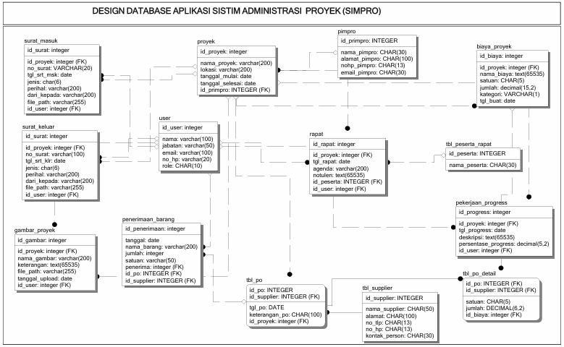
Gambar 1. Design database Simpro

