**COMPARISON OF CHARACTERS IN NOVEL “PRIDE AND PREJUDICE” BY JANE AUSTEN AND ITS FILM ADAPTATION**



**A THESIS**

Presented to Universitas Bina Sarana Informatika

In Partial Fulfilment of the Requirements to Get Strata One Degree

By

**HENDRIKUS YOAKIM PATTY ATAGORAN**

**SID : 33190123**

**Program Studi Sastra Inggris**

**Fakultas Komunikasi dan Bahasa**

**Universitas Bina Sarana Informatika**

**Jakarta**

**2024**

# OFFERING SHEET

With gratitude, the author would like to thank God Almighty for His blessings and grace so that this thesis can be completed smoothly. With all humility, the author would like to say a word of dedication to my loved ones:

1. For my beloved family, thank you to both parents, my siblings who have helped and encouraged me to complete this thesis. Without the support of my family, I might not be able to complete this thesis.
2. I am very grateful to my friends, my closest relatives, who are always there when I need help,
3. Mrs. Fitri Apriyanti S.Pd, M.Pd. who has guided and motivated me as a supervisor who has always patiently guided me, motivated and reminded me in working on this thesis from beginning to end.
4. All my dear classmates, who have helped me in providing advice and motivation for the improvement of this thesis.

**Thank you all**

# STATEMENT OF WORK ORIGINALITY

The Undersigned:

Name : Hendrikus Yoakim Patty Atagoran

SID : 33190123

Degree : Bachelor Degree (S1)

Study Program : Sastra Inggris

Faculty : Komunikasi dan Bahasa

Institution : Universitas Bina Sarana Informatika

Here by stated that the thesis I have made which is entitled:

**“Comparison of Characters in Novel Pride And Prejudice By Jane Austen and its Film Adaptation”** is original and or not a result of plagiarism and has never been published anywhere and in any form whatsoever.

Thus this statement I made solemnly with a firm belief without any pressure from any party. If after I am found to give false information and or there is a claim of plagiarism over my final assignment, I am willing to be processed under criminal and civil law and my previledge of the degree at Universitas Bina Sarana Informatika is therefore, revoked.

Signed in : Jakarta

On : 24 June 2024

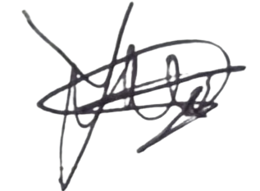 The Signee

**Hendrikus Yoakim Patty Atagoran**

# STATEMENT OF AGREEMENT ON PUBLISHING SCIENTIFIC WORK FOR ACADEMIC PURPOSE

The Undersigned:

Name : Hendrikus Yoakim Patty Atagoran

SID : 33190123

Degree : Bachelor Degree (S1)

Study Program : Sastra Inggris

Faculty : Komunikasi dan Bahasa

Institution : Universitas Bina Sarana Informatika

Here by giving approval of permission to University Bina Sarana Informatika, the Non-exclusive Royalti-Free Right over my scientific work with the title: **“Comparison of Characters in Novel Pride And Prejudice By Jane Austen and its Film Adopted”**, unless the sources stated are the result of my observation, research, management, and thoughts.

With this Non-exclusive Royalti-Free Right, Universitas Bina Sarana Informatika has a full privilege to keep, reformat, put into database, distribute, and display or publish my scientific work limited and internally, and not to upload the writer’s scientific work on Bina Sarana Informatika.

I also agree, without involving Universitas Bina Sarana Informatika to accept any forms of lawsuit due to copyright violation, data, information, interpretation and any statements if I found in my work.

Thus, This statement I made solemnly with firm belief.

Signed in : Jakarta

On : 24 June 2024

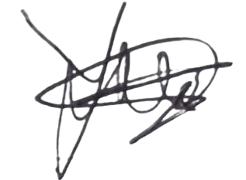 The Signee,

**Hendrikus Yoakim Patty Atagoran**

# APPROVAL SHEET

This Thesis is proposed by:

Name : Hendrikus Yoakim Patty Atagoran

SID : 33190123

Degree Program : Strata One (S1)

Study Program : Sastra Inggris

Faculty : Komunikasi dan Bahasa

Institution : Universitas Bina Sarana Informatika

Title of final Assigment : Comparison of Character in Novel Pride and Prejudice by Jane Austen and its Film Adaptation

Has been defended in period in front of the Board of Examiners and is accepted as a part of requirements needed to get SARJANA SASTRA (S.S) in Sastra Inggris Universitas Bina Sarana Informatika.

Jakarta, 29 June 2024

**Final Assignment Sponsor**

Advisor 1 : Fitri Apriyanti, S.Pd, M.Pd …………………….

**Board of Examiners:**

Examiner I : …………………….

Examiner II : …………………….

# GUIDING SHEET FOR FINAL ASSIGNMENT



# UNIVERSITAS BINA SARANA INFORMATIKA

* SID : 33190123
* Name : Hendrikus Yoakim Patty Atagoran
* Sponsor : Fitri Apriyanti, S.Pd. M.Pd
* Title : Comparison Caracters in Novel Pride And Prejudice by Jane Austen and its Film Adaptation

|  |  |  |  |
| --- | --- | --- | --- |
| **No** | **Date** | **Topic** | **Signature** |
| 1 | May 15, 2024 | First Guiding and Consulting the Title Chapter I |  |
| 2 | May 17, 2024 | Revision Chapter I |  |
| 3 | May 21, 2024 | Consulting Chapter II |  |
| 4 | May 25, 22024 | The Acceptance Chapter I and Chapter II |  |
| 5 | June 3, 2024 | Consulting Chapter III |  |
| 6 | June 8, 2024 | Revision Chapter III and Consulting Chapter IV |  |
| 7 | June 9, 2024 | The Acceptance Chapter III and Revision Chapter IV |  |
| 8 | June 11, 2024 | The Acceptance Chapter IV and Completion |  |

Table 1

* Notes to Sponsor :
* Starting Date : May 11, 2024
* Finishing Date : June 29, 2024
* Number of Guiding : 8 Times

Approved by Sponsor

Fitri Apriyanti, S.Pd, M.Pd

# ACKNOWLEDGMENT

By expressing gratitude to God Almighty, who has bestowed His grace and provision, the author can properly complete the thesis with the title "Comparison of Characters in Novel Pride and Prejudice by Jane Austen and its Film Adaptation" on time. This thesis is written in order to fulfill the requirements to achieve a Bachelor of Literature degree in the English Literature program at, the Faculty of Communication and Language, Bina Sarana Informatika University.

In completing the research and writing of this thesis, the author received a lot of help, in the form of teaching, guidance, and direction from various parties, both directly and indirectly. For that, the author expresses his deepest gratitude and appreciation to:

1. Rector of Universitas Bina Sarana Informatika.

2. Dean of Komunikasi dan Bahasa Faculity.

3. Head of Sastra Inggris.

4. Fitri Apriyanti, S.Pd, M.Pd. as the supervisor who has provided valuable guidance and has taken the time to guide, help, and advise the author sincerely and patiently in the stage of writing this thesis.

5. All lecturers of the English Literature Strata One (S1) Program at Universitas Bina Sarana Informatika, who have provided and taught the author all the material needed well.

The author's deepest gratitude goes to the author's family, especially to my parents, my siblings who helped a lot and encouraged the author in this writing stage, and all my friends who readily helped the author in completing research and writing this thesis.

Finally, the author expresses many thanks to all classmates for all their support, the author hopes that this thesis can be useful for all those who need it.

Jakarta, 14 June 2024

Hendrikus Yoakim Patty Atagoran

# ABSTRACT

**Hendrikus Yoakim Patty Atagoran (33190123) *Comparison of Characters in Novel Pride and Prejudice by Jane Austen and its Film Adaptation.***

*This research is entitled "Comparison of Characters in Novel Pride and Prejudice by Jane Austen and its Film Adaptation" This research aims to identify the differences that exist in the adaptation of novels into films. Data collection is done by reading the novel, watching the film adaptation, analyzing the main characters, and noting the differences in characters in the novel and film adaptation. Data collection uses a qualitative descriptive method. The study of adaptation theory as an approach in this analysis, to see the differences and similarities of the main characters such as Elizabeth Bennet, Mr. Darcy, and other characters in both media. Through various aspects of research such as character development, dialogue, culture, etc., this study highlights character development, reader and audience interpretation, and views on social culture in novels and films. The results of this study show that the differences and similarities in the novel and movie adaptation can affect the interpretation of the audience, which can change the interpretation of the delivery, and social criticism in the original source. The results of this study are expected to provide new insights into the influence of media adaptation on the interpretation of characters in literary works.*

***Keywords: Literary Media Adaptation, Character Comparative Analysis, Character Interpretation.***

# ABSTRAK

**Hendrikus Yoakim Patty Atagoran (33190123) Perbandingan Karakter dalam Novel Pride And Prejudice karya Jane Austen dan Film Adaptasinya.**

Penelitian ini berjudul “Comparison of Characters in Novel Pride and Prejudice by Jane Austen and its Film Adaptation” penelitian ini bertujuan untuk mengidentifikasi perbedaan yang ada pada adaptasi novel kedalam Film. Pengumpulan data dilakukan dengan cara membaca novel, menonton film adaptasinya, menganalisi karakter untama, mencatat perbedaan karakter dalam novel dan film adaptasi. Pengumpulan data menggunakan metode deskriptif kualitatif. Kajian teori adaptasi sebagai pendekatan dalam analisis ini, untuk melihat perbedaan dan persamaan karakter-karakter utama seperti Elizabeth Bennet, Mr. Darcy, dan karakter lainya dalam kedua media. Melalui berbagai aspek penelitian seperti pengembangan karakter, dialog, budaya, dan lainya, penelitian ini menyoroti tentang pengembagan karakter, penafsiran pembaca dan penonton dan pandangan terhadap sosial budaya pada novel dan film. Hasil penelitian ini menunjukan bahwa perbedaan dan persamaan dalam novel dan adaptasi film dapat berpengaruh dalam penafsiran penonton, dapat mengubah interpretasi dari penyampaian, kritik sosial dalam sumber awalnya. Dari hasil penelitian ini diharapkan dapat memberikan wawasan baru tentang pengaruh adaptasi media terhadap interpretasi karakter dalam karya sastra.

***Kata Kunci: Adaptasi Media Sastra, Analisa Perbandingan Karakter, Interpretasi Karakter.***

# TABLE OF CONTENTS

Offering Sheet **i**

Statement of Work Originality **ii**

Statement of Agreement on Publishing Scientific Work for Academic Purpose **iii**

ApprovalSheet **iv**

Guiding Sheet for Final Assignment Universitas Bina Sarana Informatika **v**

Acknowledgment **vi**

Abstract **vii**

Abstrak **viii**

Table of Contents **ix**

List of Figures **xi**

List of Table **xii**

List of Appendices **xiii**

**CHAPTER I INTRODUCTION** 1

1.1. Background of Research 1

1.2. Scope and Limitation 2

1.3. Statement of the Problem 2

1.4. Goal and Function 3

1.5. Research Methods 3

1.6. Systematical Presentation 4

**CHAPTER II THEORETICAL REVIEW** 5

2.1. Literature Review 5

2.1.1. Literature 5

2.1.2. Novel 6

2.1.3. Film Adaptation 7

2.1.4. Character 10

2.2. Relevant Studies 10

**CHAPTER III ANALYSIS** 13

3.1. Summary of the Story 13

3.2. Analysis of the Story 15

3.2.1. Character Development 15

3.2.2. Character Formation 24

3.2.3. Character Interaction 26

3.2.4. Difference in Interpretation 28

3.2.5. Historical and Social Context 29

3.2.6. Conveyance of Emotion and Motivation 30

**CHAPTER IV CONCLUSION AND SUGGESTION** 33

4.1. Conclusion 33

4.2. Suggestion 34

**BIBLIOGRAPHY** 35

**PLAGIARISM CHECK RESULTS** 36

**CURRICULUM VITAE** 37

**APPENDICES** 38

# LIST OF FIGURES

Figure i………………………………………………………………………………16

Figure ii……………………………………………………………………………...17

Figure iii……………………………………………………………………………..18

Figure iv……………………………………………………………………………..19

Figure v……………………………………………………………………………...20

Figure vi……………………………………………………………………………..21

Figure vii…………………………………………………………………………….22

Figure viii……………………………………………………………………………23

Figure ix……………………………………………………………………………..24

Figure x……………………………………………………………………………...38

Figure xi……………………………………………………………………………..39

# LIST OF TABLE

Table 1………………………………………………………………………………v

Table 2………………………………………………………………………………40

# LIST OF APPENDICES

**APPENDICES……………………………………………………………………38**

# CHAPTER I

# INTRODUCTION

## 1.1. Background of Research

Literature is the body of written works that express the human experience through the creative and artistic use of language. It can take various forms, including poetry, film, novel, drama, fiction, or non-fiction. Literature is often used to convey ideas, values, and emotions, as well as to stimulate the thoughts and feelings of readers. It serves as a way for writers to share their perspectives on the world and to influence readers in diverse and profound ways. According to (Ainy, 2022), in the modern era, the definition of literature includes new forms such as advertising copy, graffiti, and public notices that use literary attributes, such as parallelism, rhyme, rhythm, and metaphor, therefore, literature now includes popular fiction, advertising, and film to make the entire teaching and learning process more attractive and interesting.

The author discusses more about the issue of comparing characters in novels and adaptation of novels into films. (Aliyev, 2021a) Defines the novel in terms of being tested, a concept that as already mentioned, includes all novels except non-fiction. To define this concept there are several considerations and special features, the main one being that verbal objects are objects composed mainly of linguistic elements, such as punctuation marks and so on mostly written in prose. For the comparison of novels and films as in discussion, it is important for us to know about the definition of the films itself. The definition of film according to experts is an art medium that has the power to convey messages, inspire, and entertain the audience.

The understanding of film continues to develop in the world of cinematography which follows technological developments and paradigm shifts in creating audio-visual works. Art that combines visual, audio, and narrative elements for a mesmerizing experience for the audience, film also on the artistic expression of filmmakers to explore creativity in an original work. Not only as entertainment, film is an art form that affects the minds and emotions of the audience, film has a role in various aspects of real life including social, political, and cultural problems. Based on (Arulnayagam, 2023), the film is a non-print media product, it is made of visual images captured through a film camera, the construction of a film plot is different from a novel, a wise presentation of the overall action based on the scenes and based on episodes recorded in a films script. There is stage direction in a play as well as in a film, acting, photography, music, editing, and directing techniques are the main departments of filmmaking. From the outline of the title chosen by the author about the comparison of characters in novels and adaptations of novels in film form, it is also necessary to know the difference between novels and films themselves.

The research time is a theoretical framework, based on (Arulnayagam, 2023), it is indeed introductory and in particular offers an introduction to the nature, definition, function, and process of film adaptation from various sources. Since the beginning of filmmaking the source material for these films whether from Hollywood, Bollywood, or other types of films derived from classical works, epics, mythology, and later from prominent novels has become common in filmmaking to utilize source material from these print media sources. The novels offer verbal signs that acquire meaning based on musical associations, image quality, ornamental embellishment, figurative decoration, semantic implications, stylistic deviations, and pragmatic features. From all the discussion above about so many definitions of outline literature, and discussing the comparison of characters from the novel and its film adapted from Jane Austen’s novel writing entitled Pride And Prejudice, the author chose the topic comparison of characters with the title ” Comparison of characters in novel Pride And Prejudice by Jane Austen and its film adaptation”.

## 1.2. Scope and Limitation

In this research, the writer will focus on the literature aspect, to know the difference between the characters from the novel and the film adaptation. The writer focuses on an aspect that is to analyze the comparison of characters in the novel Pride And Prejudice by Jane Austen and its film adaptation.

## 1.3. Statement of the Problem

Based on the research context, the statement of the problem can be stated as follows:

a. what are the different characters from the Novel Pride And Prejudice by Jane Austen and its film adaptation?

b. what is the impact of the different characters from Novel Pride And Prejudice by Jane Austen and its film adaptation?

## 1.4. Goal and Function

The goal of this research is to analyze the difference in character interpretation of a film adopted from a novel source that can change the meaning or understanding of the characters in the original story in the novel, something like this has happened so much that it can unwittingly change the perspective of the audience, especially the audience who has read the novel first, as well as for the audience who has not read the novel, this can give a very different impression and provide differences in the medium of text and visual. This study is written to make the audience more aware of the true meaning, of a novel or film itself gives a lot of its meaning, for example from the social, cultural, and political aspects, with this difference in character, likely, the aspects conveyed by the novelist cannot be received correctly by the audience. The goal of this research is also to provide new insights into adaptation theory, add useful information or insights for various groups, such as writers, directors, students, and art activists, and be a reference for people who want to learn more about literature.

The function of this research is to inform readers about the importance of the literary value of how adaptation from text to screen can affect character interpretation, provide insight into the creative process behind adaptation, and how character design decisions can affect story interpretation.

## 1.5. Research Methods

In this research, the author uses the descriptive qualitative methods to investigate problems that develop due to explanations from various aspects, not only from the scope of novel adaptation to film and in interpreting history, the first technique is to choose novels that have been adapted into films that raise the topic of research than look for evidence that can support the point of research. Second, the data acquisition strategy includes observations from novel sources, film as well as online resources such as reference journals to solve the problem. Third, the author collects information by looking for sources from novels and film sources and using them as supporting and complementary information. The author examines the main problem, namely difference in character, and their impact on the interpretation and understanding of the information conveyed. The object of this study is a novel entitled Pride And Prejudice by Jane Austen and its film adaptation. To help readers better understand the topic being discussed, this study will provide its analysis.

Qualitative descriptive research is considered within the naturalistic research paradigm, naturalistic inquiry is defined as a constructive perspective that allows us to more easily understand a problem(Sullivan-Bolyai, 2021).

## 1.6. Systematical Presentation

This thesis is written in four chapters. The first chapter provides the research background of the writer who chose this topic as a research, it also explains the statement of the problem, the goal of the research, and the methods of the research. In the second chapter, the writer will provide five relevant studies from experts, an explanation of the novel, film, and characters, and a comparison of the characters. In addition, the writer will describe five genres of film adapted from the novel. In the third chapter, there is a summary of hereditary stories and, an analysis of the story which contains the comparison of characters and the impact of different characters to the main and actual purpose. And the fourth and last chapter the writer writes a conclusion about this research and suggestions for the readers, and other research.

To complete this research, the writer uses several procedures to find information that can support the preparation of this research. The following are the steps used by the writer to analyze this research. First, the writer chooses an outline according to the topic discussed, second, before collecting the necessary data, the writer reads novels and watches movies, then records the data information according to the topic sought in the sources under study. Third, collect the recorded information data and sort the data again. Finally, the writer analyzes it by identifying how many types the different characters appear in the novel and film under study.

# 

# CHAPTER II

# THEORETICAL FRAMEWORK

## 2.1. Literature Review

### 2.1.1. Literature

In other studies, researchers believe that an effective portion of the literature should be proportional to the results of the study (Bert & Banister, Musa & Khamis) argue that the main purpose of the literature review section is to show how limitations in other works create research gaps for other studies. Consequently, a literature review should involve a statement of personal judgment and a call to share values and ideas. It should not simply be a description of what has been published by other researchers in the form of a series of summaries, instead, it should take the form of a critical discussion that requires critical analysis (Shahsavar & Kourepaz, 2020). According to Kuang & Maya, the literature review section is one of the most important parts of the thesis, without a quality literature review, students will not be able to understand the topic of their thesis, keywords, and related studies in the field in addition, a comprehensive literature review is needed to support and explain discussion the might affect research result. Given the importance of the author of the literature review section, many studies have proven that most students cannot write the literature review section effectively. (Shahsavar & Kourepaz, 2020)

Systematic literature review articles can be broadly classified as domain-based, theory-based, and method-based. In addition to these categories of systematic literature reviews, meta-analytic reviews are also increasingly popular in various fields. There are a large number of domain-based reviews available in almost all fields of study, however, there are not many well-constructed theory and method-based reviews published in well-recognized journals.(Paul & Criado, 2020).

Overall, literature is a written work of sources of information used as a reference in various fields. This is because literature is considered to have lasting benefits and advantages in research. There is also another view that literature includes all sources of information that can be used as referenced by users, not only limited to writing but also including novels, Films, Recordings, and other objects that provide useful information. According to the ALA Glossary of Library and Information Science, literature is reading material that can be used for various intellectual and recreational activities. Its function includes assisting in the search for needed information, reinforcing the results of analysis or hypotheses, and supplementing with additional information as needed.

According to (Juntunen & Lehenkari, 2021)Research on the systematic literature review process is extensive, but an accurate explanation of how the narrative literature review process takes place is still missing in the existing literature. The purpose of this study is to improve the understanding of the narrative literature review process. By building on the process theory and literature on systematic literature review and by empirically examining the literature review process for an undergraduate thesis in European schools, we reveal that the narrative literature process is iterative, unstructured, and multilayered, contains multiple written deliverables that are cumulative in nature, and is embedded in a social context in which various official and unofficial actor guide and support early researches. This research represents a novel attempt to explain the progress of the literature review process with the help of process theory, thus offering new insights into research on literature review in general and narrative literature review in various fields of human science in particular.

Quoted from the opinions of the expert above, it can be concluded that literature is the result of human work in the form of creative ideas that have beauty value and are expressed through language media either in writing or orally and have pre-educational elements that are understood by audiences.

### 2.1.2. Novel

According to (Aliyev, 2021b)Defining the novel begins with defining the novel in a limited sense in literary philosophy, defining the novel in a limited sense, a concept that includes all novels except those called nonfiction novels, graphic novels, and novels in verse. Then, concerning Jerrold Levinson's definition of art, even a cursory examination of the objects included in the expression novel reveals that there are considerable structural-level differences between the two. One of these differences concerns word count, for while a novel is generally made up of 80-100,000 words, some novels are several times shorter (E.B. White's Charlotte's Web) and novels whose word count drastically exceeds that figure (Mark Leach's Marienbad My Love). Another significant, structural-level difference between novels relates to their constitutive material although in most cases this is simply text (Jane Austen's Pride and Prejudice), this is not the case in all cases, as there are novels that, in addition to having text as their main component, also involve graphic elements (W. G. Sebald's Vertigo) and novels that are, for the most part, graphic (Art Spiegelman's Maus). In addition, several serious structural-level differences between the novels relate to various aspects of semantic content. Take, for example, the presence of a main character, some novels have several such characters (George R. R. Martin's A Song of Ice and Fire), novels that have only one main character (Gary Paulsen's Hatchet), and novels with no main character at all (Milorad Pavić's Dictionary of the Khazars: A Novel Lexicon). Or consider the narrative structure: In some novels, the structure is chronological (Stephen King's Misery), and in some novels, the structure is non-linear (James Joyce's Ulysses). Even fiction, often treated as the paradigmatic semantic feature of the novel - does not seem to be common to all novels, as there are novels categorized as nonfiction (Rodolfo Walsh's Operación Massacre).

Given the novel's ontological diversity, attempts to define the novel may seem futile. Indeed, to do this, it is necessary to find a sufficiently informative (non-trivial) feature that is shared by all novels and possessed only by novels. But what could be such a feature, if, as explained above, the nature of novels can vary drastically about formal aspects and semantic aspects? Perhaps, after all, Morris Weitz is right when he regards the concept of the novel as essentially indefinable. However, I think the situation in defining the novel is not as difficult as it may seem initially in fact, in my opinion, 'novel' can be defined.

### 2.1.3. Film Adaptation

Film adaptation of novels is a process that combines creative artistry with technical challenges, aiming to deliver a quality story from the book to the big screen, but fans' expectations are often different, and the results are not always in line with what audiences expect. This is inseparable from the challenges faced by directors and creative teams.

This section will explore the subject of adaptation in more detail, specifically novel-to-film adaptation. According to (Quynh & Nguyenová, 2021)With the growth of popular culture and the development of technology, this field has been able to solidify its position in the film industry. However, the beginning of the process was viewed with disapproval. According to Gordon E. Slethaug, many people believed that big themes, complex language, and nuanced storylines were reduced to fit the small time frame, limited format, and visual specificity of motion pictures. One part of this portrayal still holds today.

Whether viewed positively or negatively, its impact has not gone unnoticed. In many cases, an adaptation can affect the sales of a novel, with the author benefiting from the increased number of purchases of the author's work. Similarly, it has been observed that books are likely to be released in new editions with covers of characters or scenes from the movie, while for the audience, the perception of the source material may be affected, i.e. in the situation where the adaptation is viewed. While reading, individuals then subconsciously associate the content with the images in the movie.

**a. Advantages of Adaptation**

The advantages of movie adaptation are the visual and aural aspects. In a novel. Readers must use their imagination to visualize the world the author has created in his work. Sometimes, the descriptions are so difficult that it makes it difficult for the reader to imagine the world the author has created. The main limitation is that objects and creatures, that do not exist or are alien, are involved. As shown by movies based on fantasy or science fiction, world-building or characters can be created with computer graphics. Similarly, novels that contain strong sequences make good adaptations, as the dialog is limited and the focus is on the action. Horror movies, for example, often have horrific sounds and gruesome visuals. (Quynh & Nguyenová, 2021)

**b. Disadvantages of Adaptation**

The downside of the movie adaptation is. A movie has a budget to stick to, as Linda Hutceon says “It's like sitting in a taxi, the meter is always running, and everything has to be paid for. You always see the price change wherever you go.” In contrast, a novelist has more freedom in this aspect, because the content of the book is in the decision and is not limited financially.

Furthermore, the content of the novel has to fit into a limited time frame. Since most movies are generally one and a half to two hours long, time must be used wisely. Every scene must have a purpose, whether it is to move the plot along or to develop the characters. Certain parts of the story should be revealed early or omitted entirely, while cutting out important parts may result in a strong adaptation, omitting too many scenes will be confusing, and under-explaining the plot will make viewers who haven't read the novel feel lost. Therefore, it is important to modify the story in such a way that even someone, who has no prior knowledge of the source, can follow it. By reducing the content of the novel, another problem arises. The original work may have many layers that are discovered as the story progresses, but the movie must remove them all and show the main structure. As a result, the final product may be less complex.

Another disadvantage is related to the narrator; in the case of first-person narration, where the reader is privy to the characters' thought processes and feelings, their personalities become more complicated. However, movies are usually adapted from the third point of view. The audience must pay attention to the actor's mannerisms, tone of voice, and facial expressions to discern the emotions the character is experiencing furthermore, the motives and inner workings may not be clear if not revealed out loud. Therefore, stories that focus on reflection, such as philosophical novels, are not suitable for adaptation.

Finally, a point to note is the author's writing style. While it is possible to paraphrase certain parts of dialog from the source material, the use of language and syntax, which is unique to each author, is difficult to produce.

### 2.1.4. Character

Character is a pattern of behavior, each person has a different character, character is the same as character, personality, or human nature. Whereas the definition of character is broader than these three things. Character in a person is formed in the learning process, character is not only related to a person's innate nature from birth but is formed by the environment where a person develops.

As for Maxwell, “character is not just about good or bad. More than that, character is a choice that can determine one's success or failure. Maxwell revealed that character is related to a person's learning process and the ability to deal with the process determines the level of success”.

In addition, Coon explains that “the notion of character is a subjective assessment of the personality of an individual and is also related to personality attributes that can or cannot be accepted by the wider community”. Meanwhile, according to Simon Philips, “the definition of character is a collection of values that decline to a system and underlie the attitudes, thoughts, and behaviors displayed by an individual”.

According to (Atuel et al., 2021)In describing human goodness Aris Toteles proposes two types of excellence, namely the excellence of thought and the excellence of character, the excellence of this character is not innate but is nurtured as a habit (ethos) through trial and error or repeated actions in similar situations. In other words, people deliberately engage in or pursue excellence throughout their lives. By excellence, we mean moral virtue, simplicity, humility, kindness, honesty, intelligence, and justice.

## 2.2. Relevant Studies

Relevant studies are explanations of relevant research on the topic discussed by researchers as reference material. Using references that are supported by the thoughts of experts will make the writing more accurate and not just the author's opinion or response. This study discusses problems that have been researched before, but some similarities can be used in further writing by the author. The author took several journals to be used as references in writing his thesis. The following is an explanation of the journals:

1. film adaptation of Ernest Cline's Ready Player One (2020)): The Functional of Faster Egg. This thesis analyzes and compares Ernest Cline's Ready Player One and its film adaptation. The author's research focuses on the cinematic elements used by the director to convey the content of the Ready Player One novel. This thesis also describes the different functions of popular culture references in Ready Player One and its adaptation. This research uses some of the theoretical underpinnings of adaptation by Linda Hutcheon, and mise-en-scene theory by John Gibbs. The results show that Steven Spielberg as a director has three motivations, namely economic drive, legal constraints, and personal and political motives. These motivations can be seen in the changes that occur in the movie when compared to the book, such as his motives of marketing his old films in the form of references and adding profits by exploring the value of friendship that seems more clichéd but can be understood by all ages rather than the bitter reasons for the characters to escape from a sad and dark reality.

2. investigating the differences between the novel and the film Wuthering Heights (2023): the theory of accreditation. This thesis aims to investigate the differences between the novel and the film Wuthering Heights, this research focuses on the plot structure of the novel and its film adaptation, as well as the reductions, additions, and modifications of the novel into the film. To achieve this goal, a descriptive-qualitative methodology is used to analyze the process of keratinization in terms of plot, character, and background in the novel.

3. Equalization of Veronica Roth's divergent novel and divergent film directed by Neil Burger (a comparative literature approach) (2023) This thesis examines the comparative study of interesting elements and the process of mechanization in the novel. This research aims to find out the differences in intrinsic elements that can lead to the process of equalization by adding, subtracting, and modifying stories from novels into films.

4. Love As Portrayed By The Main Character Elizabeth Bennet In Movie Adaptation Pride And Prejudice (2022) This study aims to determine the concept of love portrayed in the novel and movie. Data was collected through selected romantic scenes that illustrate the story and dialog in the film, focusing on the main character Elizabeth Bennet.

5. Requiem for a Dream: A Comparative Analysis of the Novel and the Film Adaptation (2022) This thesis offers a comparative analysis of the novel and its film adaptation. In this thesis, the fundamental thing is the depiction of a comparative analysis of the original characters in the novel in the film adaptation. Thus, each analysis also examines how the techniques used affect the perception of the reader or audience.

# 

# CHAPTER III

# ANALYSIS

## 3.1. Summary of the Story

This classic love story begins in the life of the Bennet family who lived in the English countryside in the 19th century and had five daughters namely Jane, Elizabeth, Mary, Catherine (commonly called Kitty), and Lydia. and not having a male heir was a problem for the Bennet family, because their estate could not be passed on to women, and if the daughters did not marry until Mr. Bennet died then the inheritance would go to Mr. Collins. Mrs. Bennet, their mother, is desperate for her daughters to marry wealthy men so that they can have a financially secure future. When Mr. Bingley, a newly rich man moved into their area, Mrs. Bennet was able to attract one of her daughters. After a few days of a party, Elizabeth Bennet, the smart and assertive second daughter, meets Mr. Bingley's best friend, Mr. Darcy, who seems arrogant and cold at first. At that moment, Jane finally caught Mr. Bingley's attention, and they both enjoyed the party by dancing. Meanwhile, Elizabeth listens to Mr. Darcy degrade her at the party.

Meanwhile, the relationship between Jane Bennet, the gentle eldest daughter, and Mr. Bingley blossoms, although it is hindered by the intervention of her overbearing sister, Miss Bingley. Bingley. A few days later, Elizabeth meets Mr. Wickman, a handsome soldier who is serving in the area where the Bennet family lives. Mr. Wickman tells her about his relationship with Mr. Darcy, he tells Elizabeth that he was abused by Mr. Darcy. This reinforces Elizabeth's prejudice against Mr. Darcy.

As the story progresses, Elizabeth and Mr. Darcy learn about each other, and their perceptions of each other change. Elizabeth discovers that Mr. Darcy has a softer and more loving side, which she learns and observes through Mr. Darcy's treatment and affection for her younger sister when Elizabeth along with her uncle and aunt visit Mr. Darcy's palace. While Mr. Darcy realizes that Elizabeth is a smart and valuable woman. However, their relationship continues to be hampered by social and economic barriers, as well as interference from those around them.

Meanwhile, Jane Bennet and Mr. Bingley also face obstacles in their relationship. Mr. Bingley, influenced by his sister and Mr. Darcy backs out of his relationship with Jane because he feels that the Bennet family does not match their social status. Meanwhile, the problem that befell the Bennet family was that, when the daughters were not immediately married until Mr. Bennet died, the inheritance would go to Mr. Collins, this was related to the social rules of the era, Mr. Collins himself also liked Elizabeth and came to propose to her, but the proposal was rejected by Elizabeth herself.

Elizabeth and Mr. Darcy's relationship was faced with problems coming from Lady Catharine, she was a nobleman who wanted to separate Elizabeth and Mr. Darcy. On the one hand, Jane felt depressed because of Mr. Bingley's move which resulted in the uncertainty of the relationship, Jane finally decided to visit her Papa's house in London to forget her love problems and live her new life. Amidst the problems that befall them, another problem arises, their sister Lydia runs away with Mr. Wickman, Sadness hits the Bennet family, and Mr. Bennet decides to find Lydia. and to save the family name and virtue, Lydia is married to Mr. Wickman.

The continuation of this story also tells the story of the days lived by Elizabeth who is increasingly aware of the true character of Mr. Darcy, just like Elizabeth, Mr. Darcy also feels the same way. The story continues when Mr. Darcy declares his love for Elizabeth in an unexpected way. Although surprised, Elizabeth rejects him sharply, she argues that Mr. Darcy is the mastermind of her sister Jane and Mr. Bingley's romance problem, and she also says Mr. Darcy has disrespected her family. Without realizing it, all the problems slowly improved and found a way out, and behind all the solutions was the important role of Mr. Darcy. All that Mr. Darcy did show for his love for Elizabeth. Over the next few days, Elizabeth learns more about Mr. Darcy's true character and she realizes that she may have misjudged him.

When Elizabeth discovers the truth about Mr. Darcy's role in fixing her family's problems, coupled with Mr. Darcy's true story about Mr. Wickman, her view of Mr. Darcy changes, In the end, both parties overcome their misunderstandings by realizing that they love each other. Mr. Darcy proposes once again to Elizabeth and this time she accepts him sincerely. As Jane and Mr. Bingley's relationship improves, the story ends with their deserved happiness.

## 3.2. Analysis of the Story

To examine the comparison of characters in the novel and its film adaptation, the author will analyze both sources, namely the novel and also the film adaptation of Pride and Prejudice by Jane Austen. From the results of this analysis the author will provide an overview of the comparisons that occur between the novel and its film adaptation, and the author will provide excerpts in the form of excerpts from the film adaptation in the form of developments from the novel.

### 3.2.1. Character Development

The discussion of this topic begins with the author analyzing the main characters' development in Jane Austen's Pride and Prejudice. This discussion is more about understanding how the characters change, develop, and learn from their experiences throughout the story. The author will identify key moments in the novel where these characters experience changes in their thoughts, feelings, or behaviors, as well as the factors that influence these changes. By analyzing this character development, the author can illustrate how the author builds complexity and depth in the literary work. From the explanation above, the author tries to describe or explain the changes in the main characters in the novel and the film adaptation as follows:

**a. Elizabeth Bennet**

Initially, Elizabeth was known for her smart, sharp, and slightly cynical attitude towards marriages based solely on wealth or social status. However, she also has a prejudiced attitude towards certain characters, especially Mr. Darcy whom she considers arrogant and haughty. But as the story progresses, Elizabeth undergoes a significant change in her view of Mr. Darcy and her general view of marriage. She begins to see another side of Mr. Darcy who is kind and sincere, especially when she realizes his kindness and sacrifice to help her brother, as well as when correcting their misunderstanding. Elizabeth's change in attitude towards Mr. Darcy reflects her character's growth in understanding human complexity and broadening her worldview. She learns not to simply rely on her initial prejudices, but to look behind the curtain and understand the deeper nuances of situations and characters. A more detailed explanation will be discussed as follows:

**1. Her independence**

Initially, Elizabeth is very confident in her intelligence based on personal values rather than social status. However, she also learns that relying too much on her own opinion can get her into trouble and cause misjudgment. As the story progresses, she learns to be more open to other people's points of view and consider their perspectives.

**Data 1:**

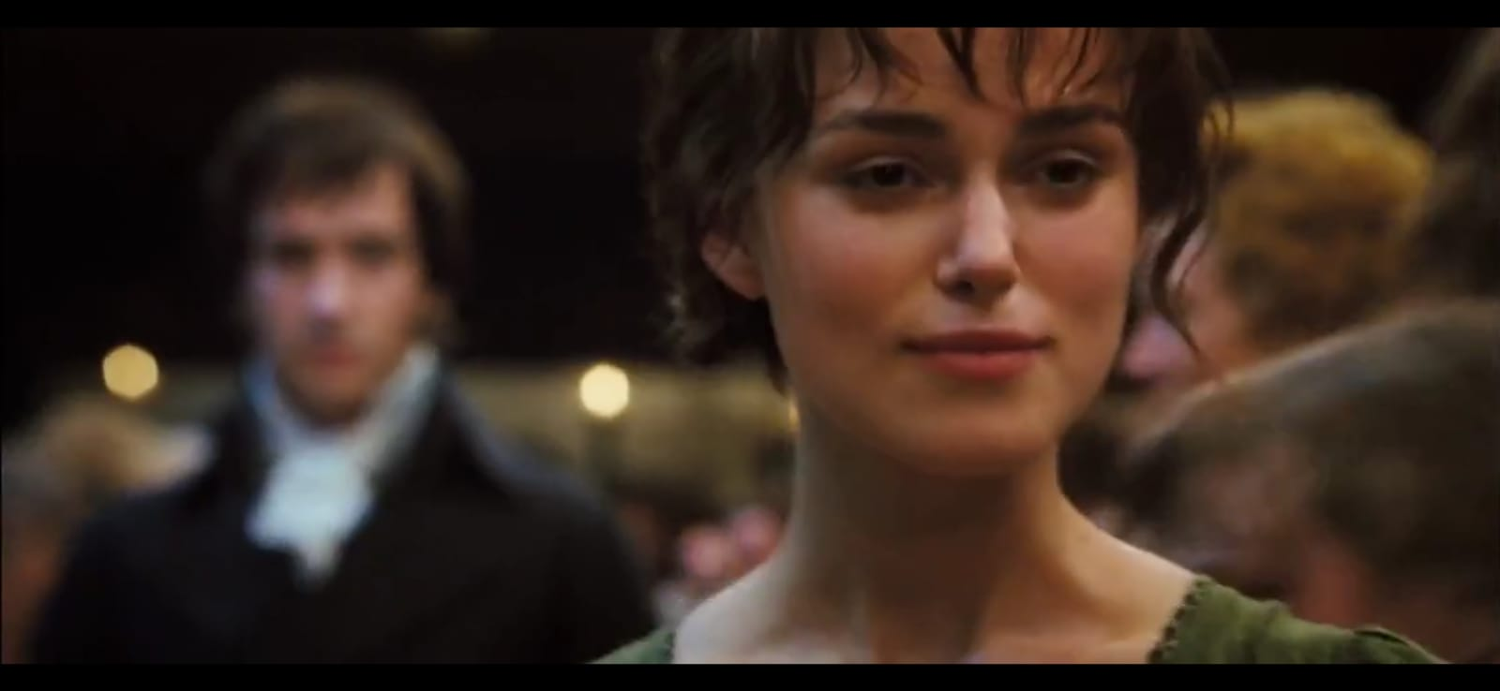

Figure I. (The first time Elizabeth meets Mr. Darcy and Jane begins to know Darcy’s initial nature.)

(Scene 13:04 - 13:32)

Elizabeth: What a wonder, who is the author of the poem, the killer of love?

Mr. Darcy: Isn't poetry the food of love? If the love is strong.

Elizabeth: If it is just, poetry will only kill it.

Mr. Darcy: So what do you think can strengthen a relationship?

Elizabeth: Just dance. No matter how bad the partner is.

Elizabeth is very confident in herself and her personal and social values and relies on her opinions, which illustrates the character's independence.

**2. Empathy and Understanding**

Through interactions with various characters, especially Mr. Darcy, Elizabeth begins to develop the ability to understand and feel empathy for others. She learns to see beyond the surface layer and understands that everyone has complex flaws and virtues.

**Data 1:**

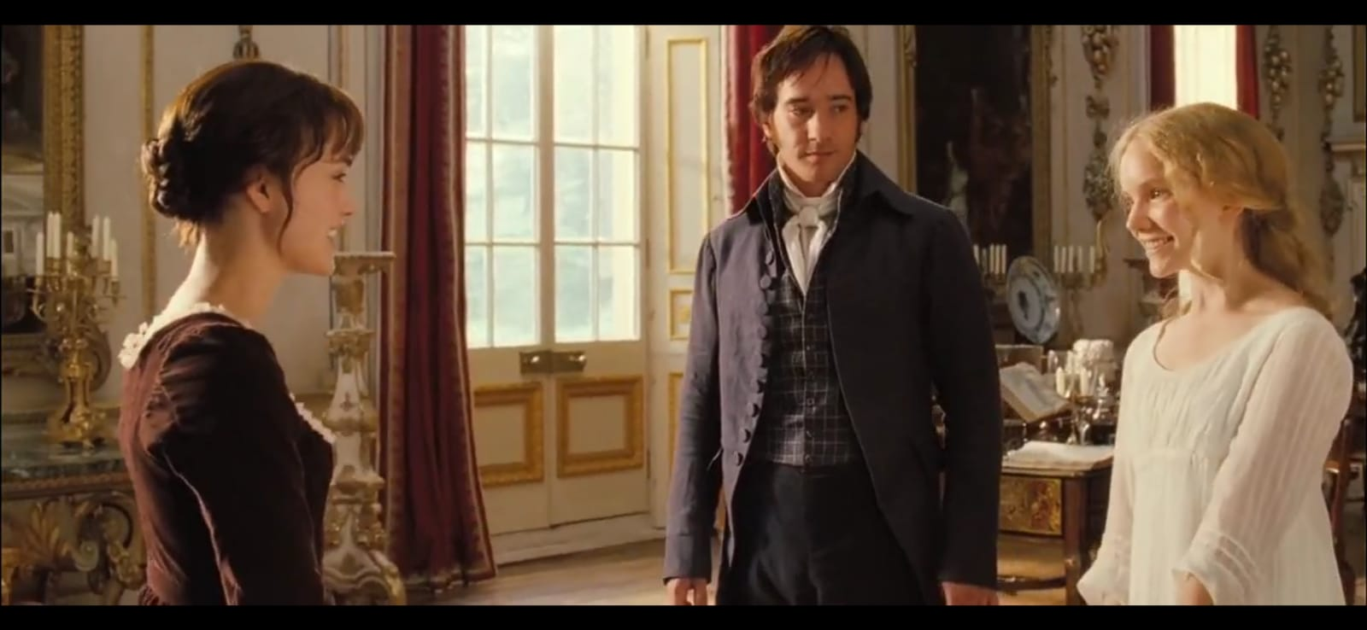

Figure II. ( Elizabeth interacts with variuos characters and she learn and understand that everyone has complex flaws and strength)

(scene 1:29:31 - 1:29:59)

Mr. Darcy: My sister, Miss Georgiana.

Georgiana: I've heard so much about you, I feel like I know you well, thank you.

Elizabeth: The piano is very nice.

Georgiana: My brother bought it for me.

Elizabeth: For a while, your brother listened to my bad playing.

Georgiana: But he said you were very good at playing.

Elizabeth: He must be making it up.

Mr. Darcy: I said not bad.

Elizabeth: Not so good as very good. I'm glad to hear that.

From the conversation above, the visual image has shows a sense of empathy and understanding from Elizabeth towards others, especially to Mr. Darcy. And she is aware of one's weaknesses.

**3. Willingness to Compromise**

Initially, Elizabeth sticks to her principles and is reluctant to compromise, especially when it comes to marriage. However, as she develops as a character, she begins to realize the importance of compromise and agreement in relationships. This is reflected in her relationship with Mr. Darcy, where she is eventually able to overcome their differences and find harmony together.

**Data 1:**

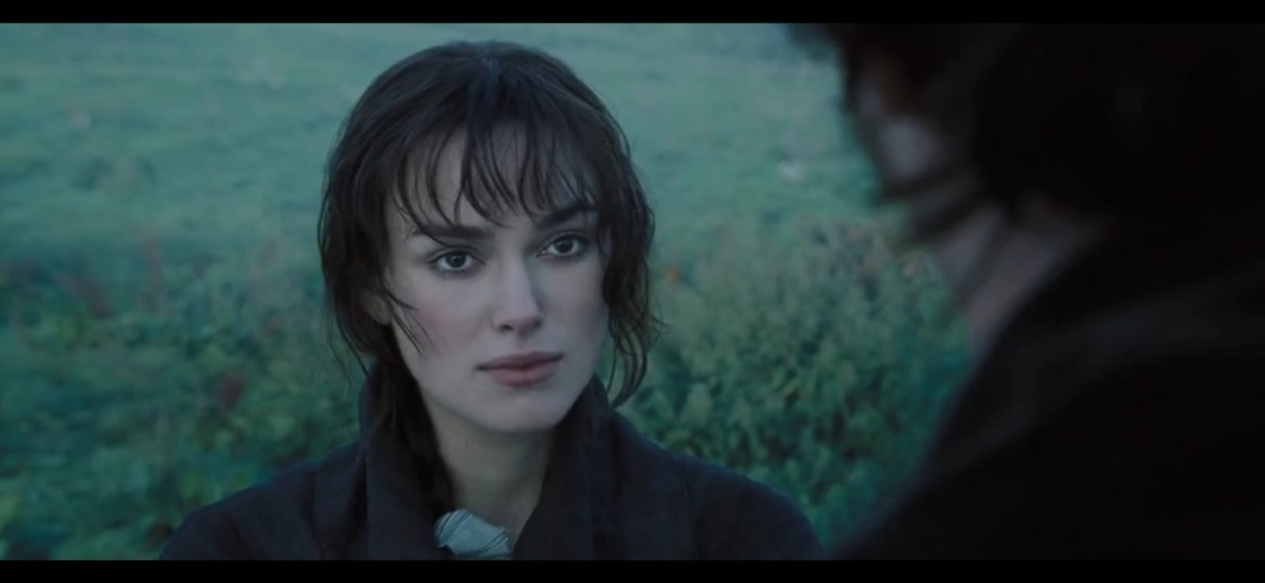

Figure III. ( The beginning of Elizabeth and Mr.Darcy starting to show love)

(scene 1:54:10 - 1:54:32)

Mr. Darcy: How can I apologize for his behavior?

Elizabeth: After what you did to Lidya and Jane, it is I who must apologize.

Mr. Darcy: You must know, I did it all for you.

Looking at the scene above, the willingness to compromise by this character is very visible and has changed from the initial character.

**4. Personal Reflection and Growth**

Elizabeth experiences significant personal growth throughout the novel. She learns from her mistakes, evaluates her actions and thoughts, and is determined to improve herself. These experiences enrich her character and make her more complex and compelling for the reader or audience.

**Data 1:**

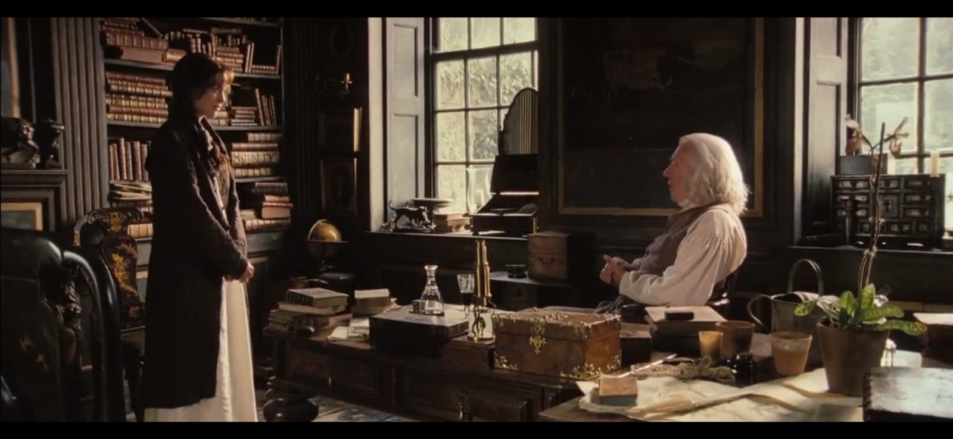

Figure IV. ( Elizabeth asked Mr.Bennet for permission to marry Mr.Darcy.)

(scene 1:56:33 - 1:57:24)

Mr. Bennet: Are you crazy? Don't you hate him?

Elizabeth: It's okay.

Mr. Bennet: He is rich. Your life will be better in the future, but are you happy?

Elizabeth: Apart from that, are there any other objections?

Mr. Bennet: Not really, he's notoriously arrogant and unpleasant.

Elizabeth: I like him. He's not arrogant, I've misbehaved with him.

Elizabeth: We misunderstood Papa, if we recognized him for what he really is.

The scene above shows a lot of character change as a result of reflection and personal growth of the character, which is very supportive of this topic of discussion.

**b. Mr. Darcy**

The character of Mr. Darcy undergoes a significant change in the novel and the film adaptation, from an arrogant and cold person to a more humble, caring, and sincere person in his relationship with Elizabeth and the people around him. The broader character growth of Mr. Darcy is as follows:

**1. Growth from Pride to Humility**

Initially, Mr. Darcy is portrayed as arrogant, cold, and haughty, especially in his interactions with Elizabeth and her family. However, as the story progresses, we see a significant change in his character. He begins to realize his personal weaknesses and mistakes, and he learns to overcome his arrogant attitude. This experience makes him understand the values of humility and modesty.

**Data 1:**

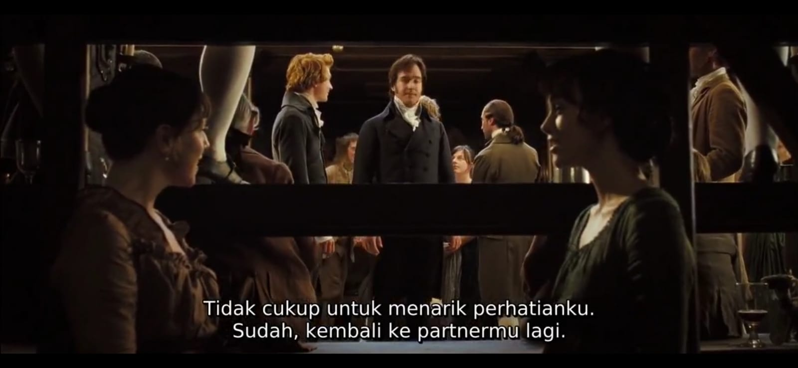

Figure V. ( Elizabeth and his friend overheard Mr.Darcy saying bad thing about Elizabeth to Mr.Bingley.)

(scene 10:09 – 10:15)

Mr. Bingley: There are many beautiful women here.

Mr. Darcy: You dance with the only beautiful woman.

Mr. Bingley: She's pretty, her sister Elizabeth, not bad either.

Mr. Darcy: No. Not enough to attract my attention.

**Data 2:**

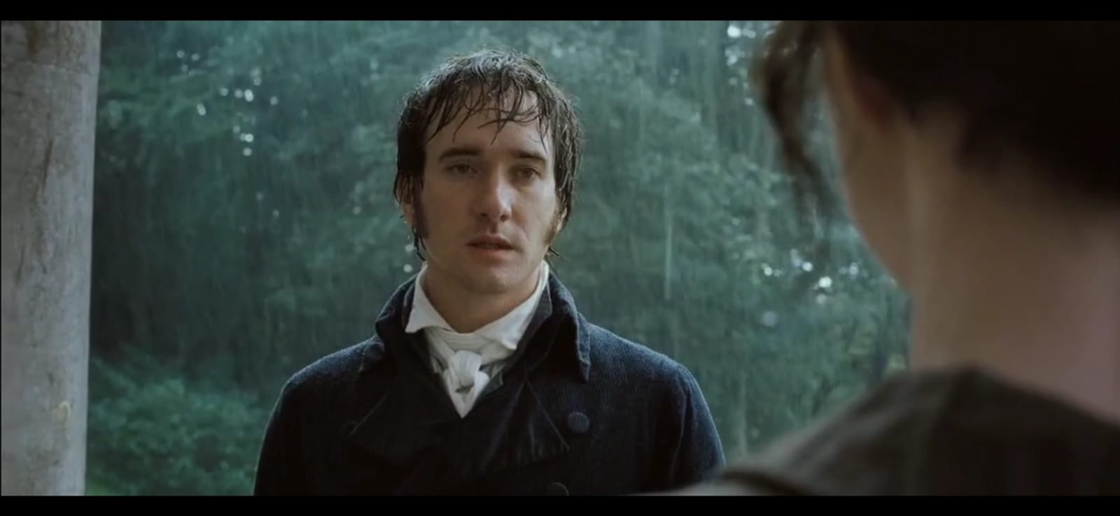

Figure VI.( Mr.Darcy expressed his feelings and apologized to Elizabeth.)

(scene 1:08:36 – 1:09:17)

Mr. Darcy: Miss Elizabeth. I have struggled for so long, and I cannot bear it any longer. I came to Rosings just for you. I struggled with logic, family expectations, my background, and my own status. I threw all of that away. Please stop my suffering. I love you. Love you very much. Please marry me.

From the scene above, we see two different scenes and times where the author wants to illustrate the character change of Mr. Darcy.

**2. Discovery of Empathy and Benevolence**

Through challenging experiences and interactions with Elizabeth, Mr. Darcy begins to discover the benevolent side of himself. He learns to be more attentive and caring towards the feelings of others, especially Elizabeth and her family. This is reflected in his actions in helping Elizabeth's sister and in his dedication to protecting those he loves.

**Data 1:**

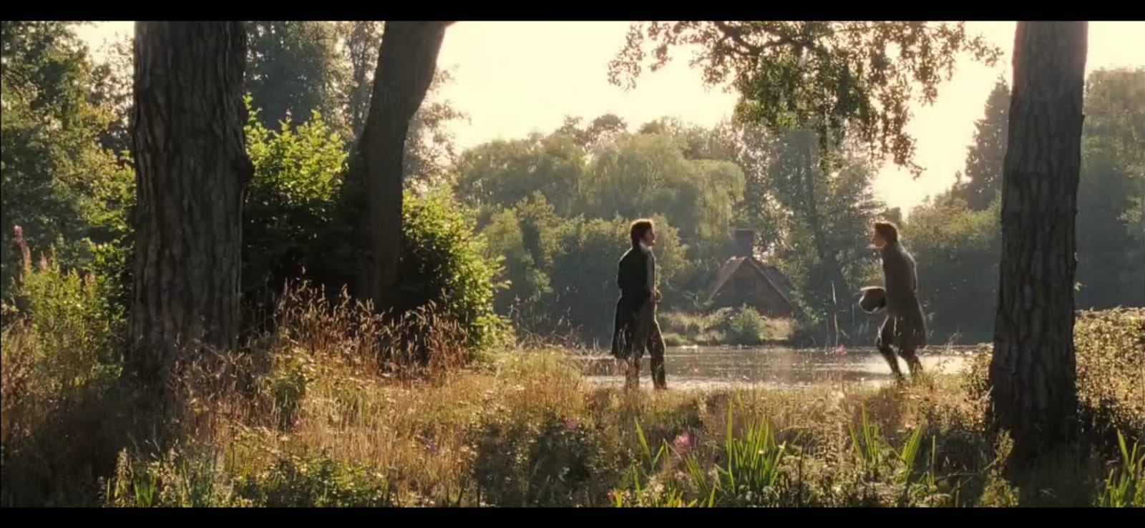

Figure VII. ( Mr.Darcy helps Mr.Bingley to meet Jane.)

(Scene 1:42:40 - 1: 43:02)

Mr. Bingley: Ah, I'm feeling terrible. So I just went in and said.

Mr. Darcy: Yeah, right.

The snippet above shows where Mr. Darcy tells and helps Mr. Bengley improve his relationship with Jane and propose to her. This shows benevolence and empathy.

**3. Change in Priorities and Values**

Initially, Mr. Darcy highly prioritized social status and wealth in finding his life partner. However, as he develops as a character, he begins to value values such as honesty, kindness, and a good personality when finding a life partner. He learns to look beyond material luxuries and judge people based on their character.

**Data 1:**

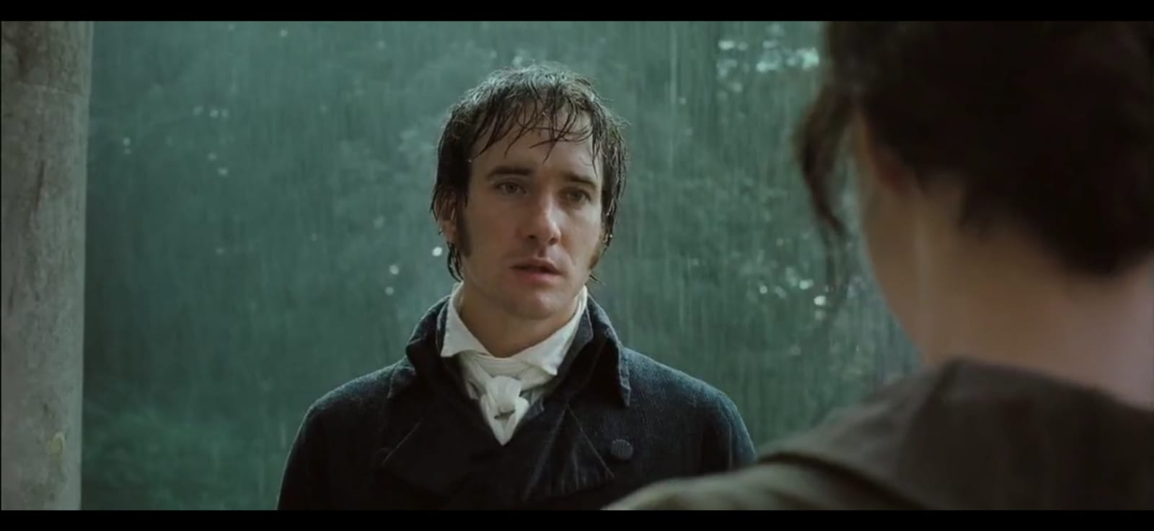

Figure VIII. ( Mr.Darcy apologizes to Elizabeth.)

(Scene 1:08:51 – 1:09:02)

Mr. Darcy: These last few months have driven me crazy. I came here just for you. No matter your social status, family expectations, your lowly background, and my own status. I threw all that away. I love you, and I want to marry you.

The scene above proves that Mr. Darcy changes in terms of priorities and values, which initially prioritized social status and wealth in finding a life partner.

**4. Sincerity of Feeling and Truth**

Mr. Darcy also undergoes a change in the way he conveys his feelings to Elizabeth. Initially, his attitude towards Elizabeth was characterized by stiffness and arrogance, but over time, he learned to be open and honest about his feelings. This is reflected in his letter to Elizabeth, where he sincerely expresses his feelings without hiding his weaknesses.

**Data 1:**

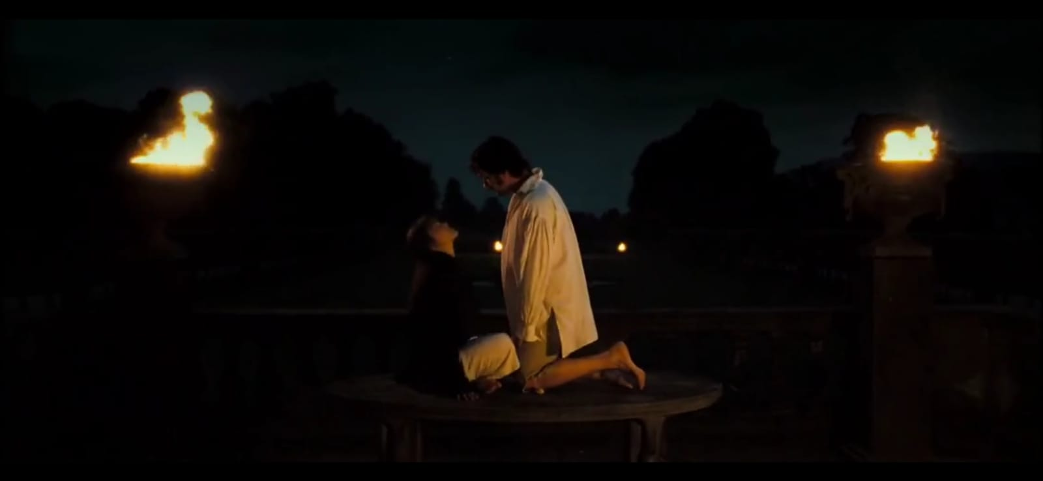

Figure IX. ( Mr.Darcy and Elizabeth have Expressed their feelings and love for each other.)

(Scene 2:00:20 – 2:01:26)

Mr. Darcy: How are you this evening?

Elizabeth: Very well, I wish you wouldn't call me “my dear”.

Mr. Darcy: Why? If I may call you. Mrs. Darcy.

From the scene, the author depicts Mr. Darcy's change in the way he conveys his feelings to Elizabeth, who was initially characterized by arrogance, this depicts sincerity of feelings and truth.

This kind of analysis will help show how the main characters experience change and growth in the novel and film adaptations.

### 3.2.2. Character Formation

Character formation in a work is influenced by a variety of factors, including interactions with other characters, life experiences, and plot development. In this topic, I will discuss an analysis of character development in Jane Austen's Pride and Prejudice and its film adaptation. This analysis involves comparing the way the main characters are presented, developed, and changed in both media.

a. Character consistency: the author will examine the extent to which the main characters in the novel remain consistent with their portrayal in the film adaptation. This involves examining whether the characters remain true to their traits, values, and motivations throughout the narrative in both the novel and the movie.

b. Differences in Visual Representation: the thesis will explore how the characters are visually shaped in the film adaptation. This includes an analysis of how the actors' costumes, settings, facial expressions, and gestures shape our understanding of the characters, and how these differences can affect our perception of them.

c. Influence of Cultural Context: the research will consider how the cultural and historical context of each medium influences character formation. For example, how the values and social norms at the time the novel was written influenced the characters, and how modern film adaptations might interpret and recontextualize the characters according to contemporary culture and times.

d. Narrative and Visual Techniques: The thesis will analyze narrative techniques in the novel and visual techniques in the film to understand how character-building is done in both media. This includes the presentation and analysis of the way authors use description, dialogue, and narration in novels, and the way directors and cinematographers visualize characters in films.

By exploring all these specs, the thesis will provide a deeper understanding of how the characters in Pride and Prejudice are shaped, interpreted, and presented in two different media, resulting in interesting and substantial discoveries. Here are the differences between the two media:

**1. In the Novel**

a. Elizabeth Bennet: Elizabeth is initially portrayed as a woman who is intelligent, brave, and slightly cynical about the social customs of her society. Through a series of conversations, interactions, and experiences, she begins to realize the inaccuracy of her opinions about people, especially about Mr. Darcy. Elizabeth's character develops through the process of acknowledging her mistakes, learning to appreciate the deeper values of other people's characters, and eventually falling in love with Mr. Darcy.

b. Mr. Darcy: Mr. Darcy is initially portrayed as an arrogant, cold, and stubborn man, especially in his initial interactions with Elizabeth. However, through experience and reflection especially after being rejected by Elizabeth and accused of bad behavior, his character begins to change. He exhibits traits such as remorse, understanding, and humility, which change Elizabeth's and the reader's perception of him.

**2. In the Movie**

a. Elizabeth Bennet: in the movie, Elizabeth's character is often shown through facial expressions, body gestures, and interactions with other characters. Her character development is presented through key scenes that highlight her changing attitudes and feelings towards Mr. Darcy. Costumes, settings, and shots are also used to portray her character in the context of different cultures and times.

b. Mr. Darcy: in the film, Mr. Darcy's character development is often shown through the actor's facial expressions, body gestures, and physical appearance. Key scenes, such as the ball in the movie, highlight his emotional and psychological changes as the story progresses. Background music and the use of sound effects can also be used to emphasize the character's change from an arrogant start to a warmer, more humble man.

The character development of Elizabeth Bennet and Mr. Darcy in both media provides a rich and in-depth portrayal of their emotional and psychological journeys throughout the story. By comparing the way character development is done in the novel and the movie, we can understand how visual adaptations strengthen or change our perception of the characters.

### 3.2.3. Character Interaction

In this topic, the author will discuss the interaction or mutual action between one character and another character in the novel and the movie, from the results of the author's analysis, the author will explain as follows:

**a. In the Novel**

1. Elizabeth Bennet's Interaction with Other Characters:

Elizabeth Bennet interacts with various characters in the novel, including her own family, her siblings, and members of the surrounding community. These interactions influence Elizabeth's perceptions and character development. For example, her relationship with her siblings, especially Jane, illustrates the depth of family relationships and provides insight into the values she holds. Elizabeth's interactions with other characters also influence the dynamics of the plot and conflicts in the story.

2. Mr. Darcy's interactions with other characters:

Mr. Darcy also engages in various interactions with other characters in the novel, especially with Elizabeth, his siblings, and other members of the Bennet family. These interactions shape the reader's perception of Mr. Darcy's character and help clarify his motivations. His initial antagonistic relationship with Elizabeth and the changing dynamics between them as the story progresses is one example of an important character interaction in the novel.

**b. In Movies**

1. Visual Interaction between Characters

In movies, character interactions are often shown visually through facial expressions, body language, and eye contact. For example, scenes where Elizabeth and Mr. Darcy stare at each other or argue visually reveal the emotional dynamics between the two.

2. Interaction in Visual and Audio Context

The setting, costumes, and props in a movie can also influence character interactions. For example, a scene in a dance hall can show complex social interactions between characters. In addition, background music and sound effects can also be used to reinforce interactions between characters, such as dramatic music in moments of conflict or romantic moments.

Through character interactions in novels and movies, readers and viewers can better understand the relationships between the characters, the dynamics of the plot, and the themes conveyed in the work. Character interaction analysis can provide deep insights into how characters influence each other and contribute to the overall development of the story.

### 3.2.4. Difference in Interpretation

The study of differences in interpretation in the novel and its film adaptation, it may include different viewpoints, emphases, or understandings between the novel Pride and Prejudice and its film adaptation. This could involve differences in emphasis on character. Plot development, theme analysis, or evaluation of the role of the medium (novel versus film) influence the interpretation of the story. The following is a snapshot or illustration of the differences in interpretation in this study:

**1. Emphasis on Specific Scenes and Dialogues**

In novels, the author may place greater emphasis on certain scenes or in-depth dialog to develop the characters. However, movie adaptations can sometimes cut or simplify these scenes in the interest of time or visual narrative clarity. For example, in the novel, the scene where Mr. Darcy expresses his feelings to Elizabeth Bennet may be given a deep emphasis, with a detailed explanation of his inner conflict. However, in the movie adaptation, this scene may be simplified to a brief moment that highlights the actors' emotional expressions.

**2. Physical Expressions and Body Language**

Novels may explore characters' physical expressions and body language in detail in narrative descriptions. Movies, on the other hand, may express these through the visual appearance and expressions of the actors, which may provide a different nuance or a more direct interpretation. For example, in novels, descriptions of a character's facial expressions or body movements may be described in detail, such as the tension on Elizabeth's face as she argues with Mr. Darcy. In a movie, actors may express these emotions through their facial expressions and body movements.

**3. Use of Internal Narration**

Novels have the advantage of presenting the internal thoughts of characters through narration. However, in films, characters' thoughts and feelings often have to be conveyed through facial expressions, actions, and dialog, which can lead to different interpretations by the audience. For example, in novels, readers have access to the characters' inner thoughts, such as their doubts or the decisions they make. For example, we can see Elizabeth's doubts through the narrative in her mind. However, in movies, the character's thoughts must be conveyed through dialog or facial expressions.

**4. Character Cuts and Additions**

Some characters or subplots in the novel may be cut or simplified in the movie adaptation to keep a more focused storyline. Conversely, some additional characters or elements may be included in the movie to add dimension or conflict that does not appear in the novel. For example, in the novel, the subplot about Bennet's family life may receive a significant portion, with explanations about family dynamics and interactions between family members. However, in the movie adaptation, some of these subplots may be cut to keep the focus on the main story. On the other hand, the film may add additional scenes or characters to add dramatization or tension that does not appear in the novel.

With these explanations and examples, readers can see how differences in interpretation between novels and movie adaptations can affect the way stories and characters are understood by the audience or readers.

### 3.2.5. Historical and Social Context

In a historical and social context, a thesis on the comparison of characters in the novel Pride and Prejudice and its film adaptation will show the following:

**1. Historical Context of the Novel**

The novel Pride and Prejudice was written by Jane Austen in the early 19th century, a period known as the Regency period in England. The writing of the novel took place during a period characterized by strict social norms, strong class distinctions, and cultural pressure towards financially rewarding marriages

**2. Influence of the Regency Period**

The Regency period influenced the social and character portrayals in the novel. Austen's works often depict middle-class and aristocratic society and highlight the role of women in a society that is limited to marriage and social status.

**3. Influence of Culture and Social Norms**

Strict social norms and cultural expectations of marriage, class, and gender play an important role in the formation of characters and conflicts in novels. For example, the expectation of finding a financially and socially suitable life partner greatly influences the relationships between the main characters.

**4. Film Adaptations and the Modern Social Context**

Film adaptations of the novel often try to reinterpret the story and characters in a more modern social context. This can include an emphasis on values that are more relevant to modern audiences as well as a freer interpretation of the relationships between characters.

**5. Social Change in Film**

Film adaptations of Pride and Prejudice often add or change some aspects of the story or characters to reflect social changes that have occurred since the novel was first written. This could include an emphasis on gender equality, a more in-depth explanation of social dynamics, or other updates that update the story for modern audiences.

By paying attention to these historical and social contexts, this analysis can shed light on how these factors influence the portrayal of characters in the novel and its film adaptation, as well as how the interpretation of the story may change or be reinterpreted in different cultural contexts.

### 3.2.6. Conveyance of Emotion and Motivation

On the topic of comparing characters in the novel Pride and Prejudice and its movie adaptation, the delivery of emotions and character motivations can be an important focus. Here are some points that can be explored:

**1. Emotion Delivery Through Language and Action**

An analysis can be done of how the novel and movie convey characters' emotions through their language, actions, and expressions. For example, in the novel, when Elizabeth Bennet rejects Mr. Darcy's first offer of marriage, the author uses dialogue and narrative description to convey the decision with deep emotional clarity. In the movie, this scene may be amplified by the strong facial expressions of the actress playing Elizabeth, showing courage and firmness in her decision.

**2. Character Motivation in Social and Cultural Context**

This research can explore how character motivations in novels are influenced by the social and cultural context at the time of writing. For example, character motivations such as Mrs. Bennet's desire to marry off her daughters financially and socially are heavily influenced by the social norms of the time. In a novel, the author might use dialogue and narration to explain the pressure Mrs. Bennet feels to marry off her daughters quickly. In the film, facial expressions and actions depicting Mrs. Bennet's anxiety and desire may clarify her motivation.

**3. Differences in Emphasis on Emotion and Motivation**

Comparisons can be made between how novels and movies emphasize certain characters' emotions and motivations. For example, in novels, the author may place greater emphasis on the characters' internal monologues to show their feelings and thoughts in detail. Whereas in the film adaptation, the director may use background music or dramatic settings to increase the emotional intensity in certain scenes, such as when Mr. Darcy expresses his love for Elizabeth.

**4. Visual Expression in Film**

In film adaptations, analysis can be done on how visual expressions, such as facial expressions, body movements, and settings are used to convey characters' emotions and motivations. For example, in movies, detailed facial expressions, body movements, and visual settings can be used to convey characters' emotions and motivations more directly. For example, when Elizabeth receives a marriage proposal from Mr. Collins, her expression of disappointment and confusion can be clearly shown through her facial expressions and the somber setting of the scene.

**5. Differences in Interpretation of Emotions and Motivations**

This topic can explore how the differences between written and visual mediums affect the way a character's emotions and motivations are interpreted by readers and viewers. For example, readers of novels may have more room to imagine the emotional nuances and motivations of characters based on the descriptions provided by the author. However, in watching a movie, the audience must control the visual expressions and interpretations of the actors to understand the feelings and motivations of the characters.

Using this analysis and examples, the author can present a more in-depth analysis of how characters' emotions and motivations are conveyed and understood in the novel and film adaptations of Pride and Prejudice.

# 

# CHAPTER IV

# CONCLUSION AND SUGGESTION

In this chapter, the author makes conclusions and suggestions based on the results of the research. After analyzing the comparison of characters in Jane Austen's Pride and Prejudice novel and its film adaptation. The researcher will give some conclusions and suggestions to the reader, first, the researcher will provide conclusions from the entire research.

## 4.1. Conclusion

This research's conclusion may include comparing the main characters in Jane Austen’s Pride and Prejudice novel and its film adaptation. This could focus on how the characters are portrayed and developed in both media. For example, the research might find differences in the way the characters of Elizabeth Bennet and Mr. Darcy are presented in the novel and movie. This could include aspects such as confidence, social background, wealth, and interpersonal relationships. The conclusion of this research can provide insight into how the visual interpretation of these characters can affect our understanding of the literary work. Within the overall research, possible conclusions are drawn. Differences in emphasis, the research may highlight the differences in emphasis between the novel and its movie adaptation in portraying the main characters. There may be characters that are emphasized more in one medium than the other, and this may affect the way we understand the narrative and themes presented. Furthermore, this research also discusses visual interpretation. In this section, the research highlights how the visual interpretation of the characters in the movie can enrich or change the reader’s perspective on the original works. This can involve analyzing how expression, body movements, and visual settings can strengthen or change our interpretation of our character in the story. It also highlights the cuts and additions of scenes in these two mediums. The conclusion of this study also includes the differences in cuts and additions of scenes or dialog between the novel and its film adaptation. This can affect our understanding of the characters and plot as a whole, as well as show how the story is conveyed to the audience or reader. Then there is also this study discussing fidelity to the source. This study evaluates the extent to which the film adaptation sticks to the source novel in describing the characters and conflicts in the story. This can raise questions about the creative decisions made by the directors and screenwriters in presenting the work in visual form. It also highlights the strong cultural influences in the where, the source material is set, highlighting how the cultural context of filmmaking can influence the interpretation and representation of characters in the story. This can include an understanding of values and social norms that may differ between the time of the novel and the time of the film adaptation. Changes in emotion and nuance are also discussed, as is how the reception and response to characters in novels and movies can vary between readers and viewers. This may reflect the personal preferences, life experiences, and cultural backgrounds of different individuals. Analyzing and comparing these aspects can provide a deeper understanding of how stories and characters are prepared and delivered in various media. The research thus not only provides insight into differences between novel and film adaptations, but also shows the importance of considering context, media, and cultural influences in literary and visual analysis.

## 4.2. Suggestion

For other researchers to see the importance of contributing to adaptation studies from research that can make a valuable contribution to the study of literary adaptation to visual media. By understanding how characters and narratives are presented in both media, we can develop a deeper understanding of the adaptation process and how literary works can be transferred to the big screen in an effective way. There are many approaches that the author has described in this thesis: by continuing the research with these approaches, other researchers can gain a more holistic understanding of the comparison of characters in novels and their film adaptations, as well as the contribution of these adaptations to the interpretation and appreciation of the original literary works. And for the universities involved in this research to provide space or facilities for the study of literary to visual adaptations and facilitate interactive research, support collaborative research projects, and encourage more active interdisciplinary collaboration in the future. By taking these steps, universities can become centers of excellence in literary as well as visual studies.

# BIBLIOGRAPHY

Ainy, P. Dr. S. (2022). Definitions of „Literature‟ in Bangladesh EFL Context – an Empirical Study. *International Journal of Research and Innovation in Social Science*, *06*(05), 18–28. https://doi.org/10.47772/ijriss.2022.6502

Aliyev, A. (2021a). What is a novel? *Estetika*, *58*(1), 19–34. https://doi.org/10.33134/EEJA.215

Aliyev, A. (2021b). What is a novel? *Estetika*, *58*(1), 19–34. https://doi.org/10.33134/EEJA.215

Arulnayagam, R. (2023). A STUDY ON ENGLISH NOVELS INTO FILM ADAPTATIONS. In *Journal of Indian languages and Indian literature in English* (Issue 01). www.jilile.in

Atuel, H. R., Barr, N., Jones, E., Greenberg, N., Williamson, V., Schumacher, M. R., Vermetten, E., Jetly, R., & Castro, C. A. (2021). Understanding Moral Injury From a Character Domain Perspective. *Journal of Theoretical and Philosophical Psychology*, *41*(3), 155–173. https://doi.org/10.1037/teo0000161

Juntunen, M., & Lehenkari, M. (2021). A narrative literature review process for an academic business research thesis. *Studies in Higher Education*, *46*(2), 330–342. https://doi.org/10.1080/03075079.2019.1630813

Paul, J., & Criado, A. R. (2020). The art of writing literature review: What do we know and what do we need to know? *International Business Review*, *29*(4). https://doi.org/10.1016/j.ibusrev.2020.101717

Quynh, T., & Nguyenová, A. (2021). *Západočeská univerzita v Plzni A Comparison of Jane Austen’s novel Pride and Prejudice and Its Film Adaptation*.

Shahsavar, Z., & Kourepaz, H. (2020). Postgraduate students’ difficulties in writing their thesis literature review. *Cogent Education*, *7*(1). https://doi.org/10.1080/2331186X.2020.1784620

Sullivan-Bolyai, A. (2021). *Qualitative Description: A “How-To” Guide Item Type Other*. https://doi.org/10.13028/8vwe-xc61

# PLAGIARISM CHECK RESULTS

# 

# CURRICULUM VITAE

**1. Personal Data**

SID : 33190123

Full Name : Hendrikus Yoakim Patty Atagoran

Place & Date of Brith : Epubele, 24 September 1999

Addres : Jl. Salemba Beluntas No.B.30, RT.12/RW.5, Paseban, Senen, Jakarta Pusat

Email : [hendrikatagoran29@gmail.com](mailto:hendrikatagoran29@gmail.com)

**2. Education**

1. SDI Epubele (2005-2011)

2. SMPK Phaladhya (2011-2014)

3. SMK Surya Mandala (2014-2017



Jakarta, 24 June 2024

**Hendrikus Yoakim Patty Atagoran**

# APPENDICES

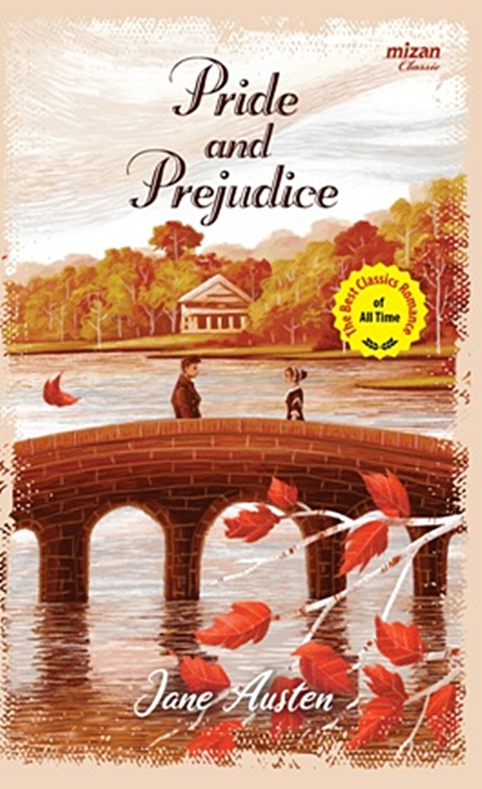**Cover of Pride and Prejudice Novel**

Figure X

**Cover of Pride and Prejudice Film Adaptation**

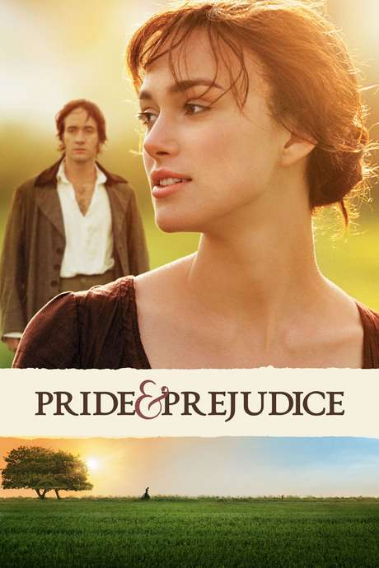

Figure XI

**Cast List in Pride and Prejudice Film Adaptation**

|  |  |  |
| --- | --- | --- |
| Keira Knightley  As  Elizabeth Bennet | Matthew Macfadyen  As  Mr. Darcy | Rosamund Pike  As  Jane Bennet |
| Simon Woods  As  Mr. Bingley | Donald Sutherland  As  Mr. Bennet | Brenda Blethyn  As  Mrs. Bennet |
| Rupert Friend  As  Mr. Wickham | Jane Malone  As  Lydia Bennet | Tom Hollander  As  Mr. Collins |

Table 2