|  |
| --- |
|  |

|  |  |
| --- | --- |
| Nama Dosen | : ATRI NODI MAIZA PUTRA |
| Mata Kuliah | : LAB. AKUNTANSI DASAR [ 032 ] |
| Kelas | : 62.2A.31 |

|  |  |  |  |  |  |
| --- | --- | --- | --- | --- | --- |
| **No.** | **Nim** | **Nama** | Nilai HER | Dosen Penilai | Tanggal Input |
| 32 | 62220011 | RIZKY LAMGANDA TUA PANGARIBUAN | 75 | TNM | 2023-08-25 14:18:25 |

|  |  |  |
| --- | --- | --- |
| Waktu Cetak Tanggal 25-Aug-2023   |  |  | | --- | --- | | 032 | LAB. AKUNTANSI DASAR |   02:25:04 |

|  |
| --- |
|  |

|  |  |
| --- | --- |
| Nama Dosen | : ATRI NODI MAIZA PUTRA |
| Mata Kuliah | : LAB. AKUNTANSI DASAR [ 032 ] |
| Kelas | : 63.8B.07 |

|  |  |  |  |  |  |
| --- | --- | --- | --- | --- | --- |
| **No.** | **Nim** | **Nama** | Nilai HER | Dosen Penilai | Tanggal Input |
| 34 | 63190201 | TIMOTIUS TAHI | 75 | TNM | 2023-08-25 14:29:34 |

|  |  |  |
| --- | --- | --- |
| Waktu Cetak Tanggal 25-Aug-2023   |  |  | | --- | --- | | 032 | LAB. AKUNTANSI DASAR |   02:29:55 |

|  |
| --- |
|  |

|  |  |
| --- | --- |
| Nama Dosen | : ATRI NODI MAIZA PUTRA |
| Mata Kuliah | : LAB. AKUNTANSI DASAR [ 032 ] |
| Kelas | : 63.6A.04 |

|  |  |  |  |  |  |
| --- | --- | --- | --- | --- | --- |
| **No.** | **Nim** | **Nama** | Nilai HER | Dosen Penilai | Tanggal Input |
| 37 | 63200141 | ANNISA WULANDARI | 75 | TNM | 2023-08-25 14:39:39 |

|  |  |  |
| --- | --- | --- |
| Waktu Cetak Tanggal 25-Aug-2023   |  |  | | --- | --- | | 032 | LAB. AKUNTANSI DASAR |   02:39:44 |
|  |
|  |

|  |  |
| --- | --- |
| Nama Dosen | : ATRI NODI MAIZA PUTRA |
| Mata Kuliah | : LAB. AKUNTANSI DASAR [ 032 ] |
| Kelas | : 63.4A.37 |

|  |  |  |  |  |  |
| --- | --- | --- | --- | --- | --- |
| **No.** | **Nim** | **Nama** | Nilai HER | Dosen Penilai | Tanggal Input |
| 43 | 63210572 | INDHAH RAHAYU | 75 | TNM | 2023-08-25 14:52:57 |

|  |  |  |
| --- | --- | --- |
| Waktu Cetak Tanggal 25-Aug-2023   |  |  | | --- | --- | | 032 | LAB. AKUNTANSI DASAR |   02:53:10 |

|  |
| --- |
|  |

|  |  |
| --- | --- |
| Nama Dosen | : ATRI NODI MAIZA PUTRA |
| Mata Kuliah | : [ 0049 ] |
| Kelas | : 63.8C.07 |

|  |  |  |  |  |  |
| --- | --- | --- | --- | --- | --- |
| **No.** | **Nim** | **Nama** | Nilai HER | Dosen Penilai | Tanggal Input |
| 33 | 63190113 | ELKHEREL ERWIANA MAMAHIT | 75 | FBS | 2023-08-29 16:34:23 |
| 33 | 63190537 | SYAHWAL FAUZI FIRMANSYAH |  | TNM | 2023-08-28 14:39:31 |

|  |
| --- |
| Waktu Cetak Tanggal 29-Aug-2023 04:44:02 |

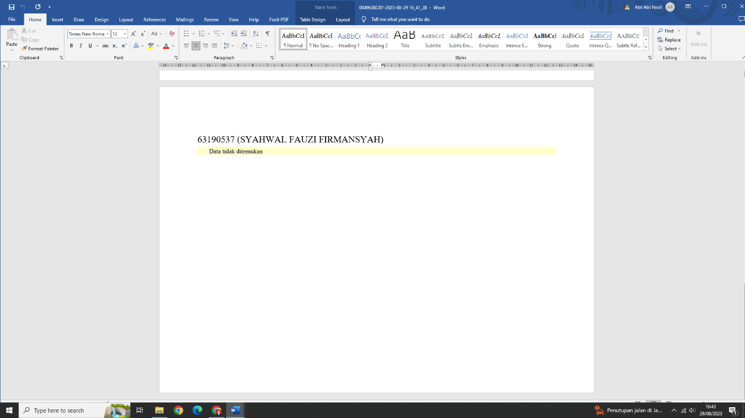

|  |
| --- |
|  |

|  |  |
| --- | --- |
| Nama Dosen | : ATRI NODI MAIZA PUTRA |
| Mata Kuliah | : [ 0055 ] |
| Kelas | : 63.6A.38 |

|  |  |  |  |  |  |
| --- | --- | --- | --- | --- | --- |
| **No.** | **Nim** | **Nama** | Nilai HER | Dosen Penilai | Tanggal Input |
| 35 | 63200053 | M DIKI WAHYUDI | 75 | FBS | 2023-08-29 16:37:18 |
| 35 | 63200566 | PUTRI KHOIROTUNNISA SASHI KIRANA | 75 | TNM | 2023-08-28 14:16:04 |

|  |
| --- |
| Waktu Cetak Tanggal 29-Aug-2023 04:46:02 |
|  |

|  |  |
| --- | --- |
| Nama Dosen | : ATRI NODI MAIZA PUTRA |
| Mata Kuliah | : [ 0050 ] |
| Kelas | : 63.6A.05 |

|  |  |  |  |  |  |
| --- | --- | --- | --- | --- | --- |
| **No.** | **Nim** | **Nama** | Nilai HER | Dosen Penilai | Tanggal Input |
| 36 | 63200074 | IMANIA FAHMI | 80 | SHT | 2023-08-28 14:33:35 |

|  |
| --- |
| Waktu Cetak Tanggal 29-Aug-2023 04:47:55 |

|  |
| --- |
|  |

|  |  |
| --- | --- |
| Nama Dosen | : ATRI NODI MAIZA PUTRA |
| Mata Kuliah | : LAB. AKUNTANSI DASAR [ 032 ] |
| Kelas | : 63.6A.04 |

|  |  |  |  |  |  |
| --- | --- | --- | --- | --- | --- |
| **No.** | **Nim** | **Nama** | Nilai HER | Dosen Penilai | Tanggal Input |
| 37 | 63200141 | ANNISA WULANDARI | 75 | TNM | 2023-08-25 14:39:39 |

|  |
| --- |
| Waktu Cetak Tanggal 29-Aug-2023 04:49:21 |

|  |
| --- |
|  |

|  |  |
| --- | --- |
| Nama Dosen | : ATRI NODI MAIZA PUTRA |
| Mata Kuliah | : [ 0055 ] |
| Kelas | : 63.6A.05 |

|  |  |  |  |  |  |
| --- | --- | --- | --- | --- | --- |
| **No.** | **Nim** | **Nama** | Nilai HER | Dosen Penilai | Tanggal Input |
| 38 | 63200183 | RICKY GUNAWAN | 75 | TNM | 2023-08-28 14:18:54 |
| 38 | 63200244 | PUTRI AYU NINGRUM | 75 | TNM | 2023-08-28 14:18:54 |

|  |
| --- |
| Waktu Cetak Tanggal 29-Aug-2023 04:52:21 |

|  |
| --- |
|  |

|  |  |
| --- | --- |
| Nama Dosen | : ATRI NODI MAIZA PUTRA |
| Mata Kuliah | : [ 0055 ] |
| Kelas | : 63.6B.37 |

|  |  |  |  |  |  |
| --- | --- | --- | --- | --- | --- |
| **No.** | **Nim** | **Nama** | Nilai HER | Dosen Penilai | Tanggal Input |
| 39 | 63200432 | EYES PRASETYANINGRUM |  | TNM | 2023-08-29 16:53:53 |

|  |
| --- |
| Waktu Cetak Tanggal 29-Aug-2023 04:54:01 |

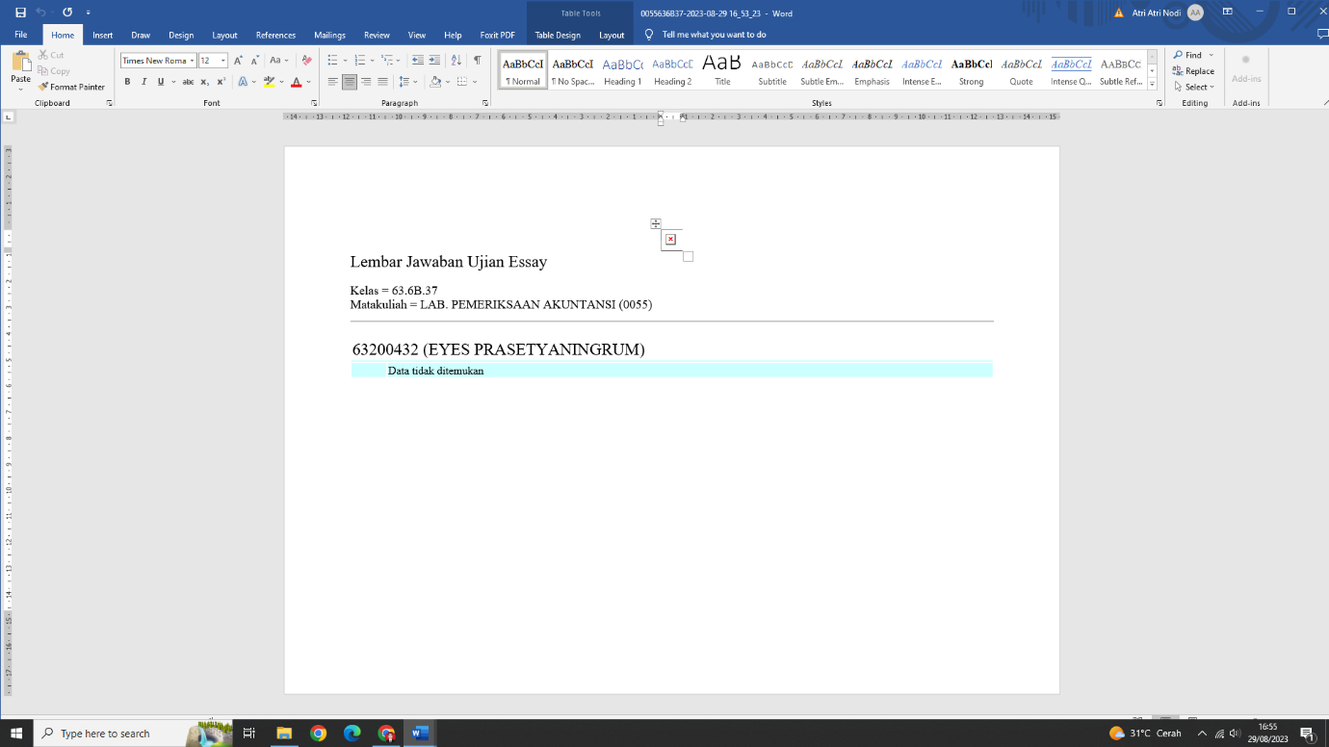

|  |
| --- |
|  |

|  |  |
| --- | --- |
| Nama Dosen | : ATRI NODI MAIZA PUTRA |
| Mata Kuliah | : LAB. AKUNTANSI DASAR [ 032 ] |
| Kelas | : 63.6A.31 |

|  |  |  |  |  |  |
| --- | --- | --- | --- | --- | --- |
| **No.** | **Nim** | **Nama** | Nilai HER | Dosen Penilai | Tanggal Input |
| 40 | 63200664 | RINI MUSTIKOWATI |  | TNM | 2023-08-29 17:00:40 |

|  |
| --- |
| Waktu Cetak Tanggal 29-Aug-2023 05:01:47 |

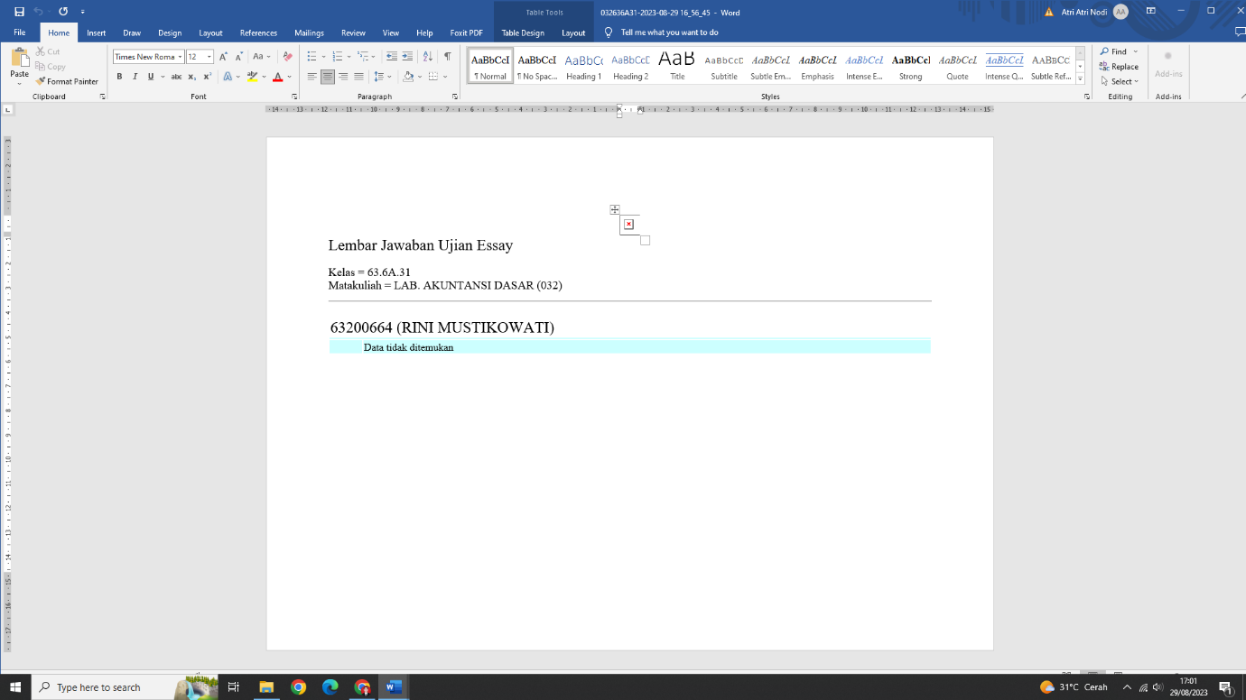

|  |
| --- |
|  |

|  |  |
| --- | --- |
| Nama Dosen | : ATRI NODI MAIZA PUTRA |
| Mata Kuliah | : LAB. AKUNTANSI DASAR [ 032 ] |
| Kelas | : 63.4A.11 |

|  |  |  |  |  |  |
| --- | --- | --- | --- | --- | --- |
| **No.** | **Nim** | **Nama** | Nilai HER | Dosen Penilai | Tanggal Input |
| 41 | 63210375 | FITRI DIAN NINGSIH | 75 | TNM | 2023-08-28 14:21:16 |

|  |
| --- |
| Waktu Cetak Tanggal 29-Aug-2023 05:04:47 |

|  |
| --- |
|  |

|  |  |
| --- | --- |
| Nama Dosen | : ATRI NODI MAIZA PUTRA |
| Mata Kuliah | : [ 0049 ] |
| Kelas | : 63.4C.01 |

|  |  |  |  |  |  |
| --- | --- | --- | --- | --- | --- |
| **No.** | **Nim** | **Nama** | Nilai HER | Dosen Penilai | Tanggal Input |
| 42 | 63210545 | AKHMAD SANI | 75 | TNM | 2023-08-29 17:06:47 |
| 42 | 63210553 | ABYAN FAHJRI | 75 | TNM | 2023-08-29 17:06:47 |
| 42 | 63210624 | AISYAH RAMADHAN |  | TNM | 2023-08-29 17:06:47 |

|  |
| --- |
| Waktu Cetak Tanggal 29-Aug-2023 05:07:01 |

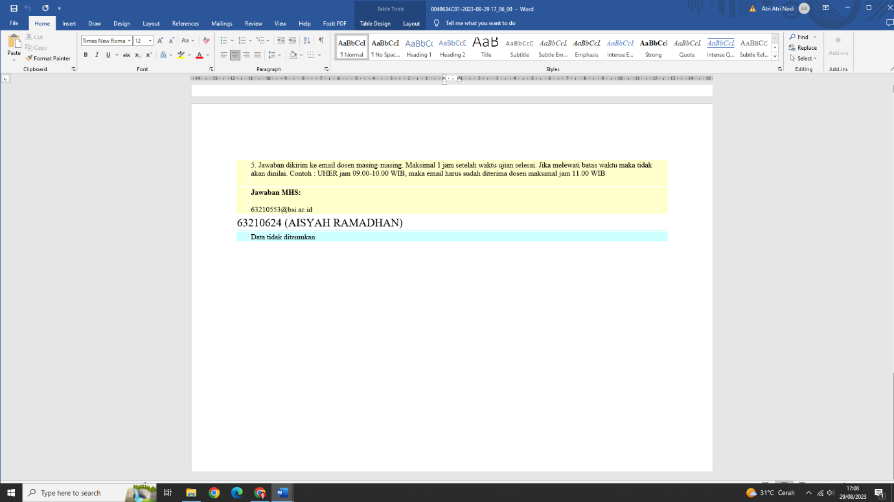

|  |
| --- |
|  |

|  |  |
| --- | --- |
| Nama Dosen | : ATRI NODI MAIZA PUTRA |
| Mata Kuliah | : LAB. AKUNTANSI DASAR [ 032 ] |
| Kelas | : 63.4A.37 |

|  |  |  |  |  |  |
| --- | --- | --- | --- | --- | --- |
| **No.** | **Nim** | **Nama** | Nilai HER | Dosen Penilai | Tanggal Input |
| 43 | 63210572 | INDHAH RAHAYU | 75 | TNM | 2023-08-25 14:52:57 |

|  |
| --- |
| Waktu Cetak Tanggal 29-Aug-2023 05:09:05 |

|  |
| --- |
|  |

|  |  |
| --- | --- |
| Nama Dosen | : ATRI NODI MAIZA PUTRA |
| Mata Kuliah | : [ 0049 ] |
| Kelas | : 63.4B.05 |

|  |  |  |  |  |  |
| --- | --- | --- | --- | --- | --- |
| **No.** | **Nim** | **Nama** | Nilai HER | Dosen Penilai | Tanggal Input |
| 44 | 63210673 | NATHASYA YULIANA LAWE KUMANIRENG |  | TNM | 2023-08-29 17:10:57 |

|  |
| --- |
| Waktu Cetak Tanggal 29-Aug-2023 05:11:02 |

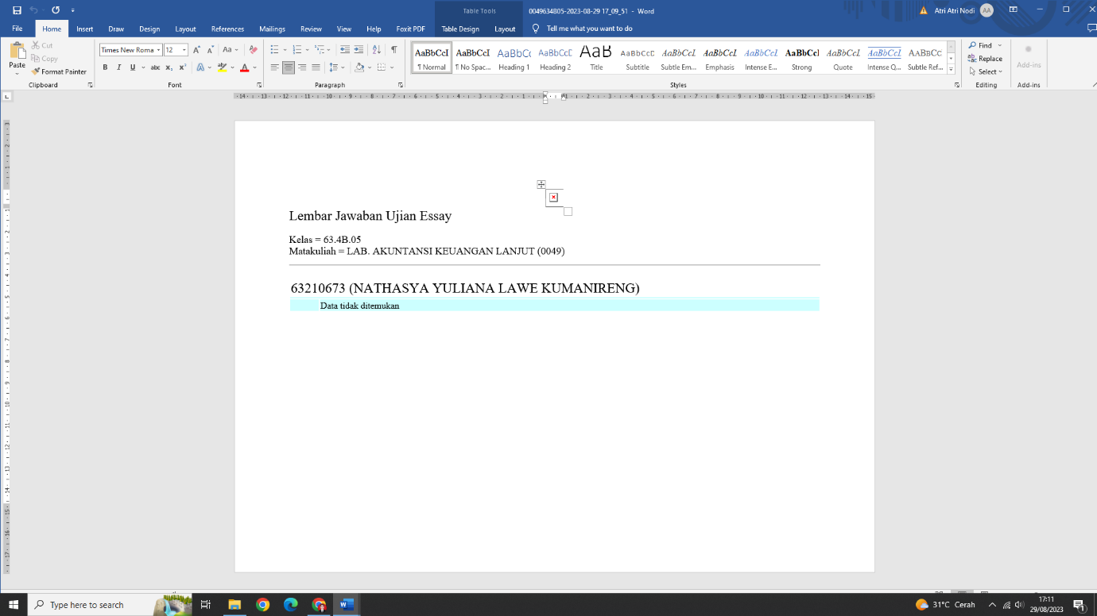

|  |
| --- |
|  |

|  |  |
| --- | --- |
| Nama Dosen | : ATRI NODI MAIZA PUTRA |
| Mata Kuliah | : LAB. AKUNTANSI DASAR [ 032 ] |
| Kelas | : 63.2C.07 |

|  |  |  |  |  |  |
| --- | --- | --- | --- | --- | --- |
| **No.** | **Nim** | **Nama** | Nilai HER | Dosen Penilai | Tanggal Input |
| 45 | 63220088 | MARIA SAVINA KEWA SULE KOLIN |  | TNM | 2023-08-28 14:44:38 |
| 45 | 63220120 | RISA AMANDA PUTRI | 75 | SHT | 2023-08-28 14:30:19 |

|  |
| --- |
| Waktu Cetak Tanggal 29-Aug-2023 05:13:12 |

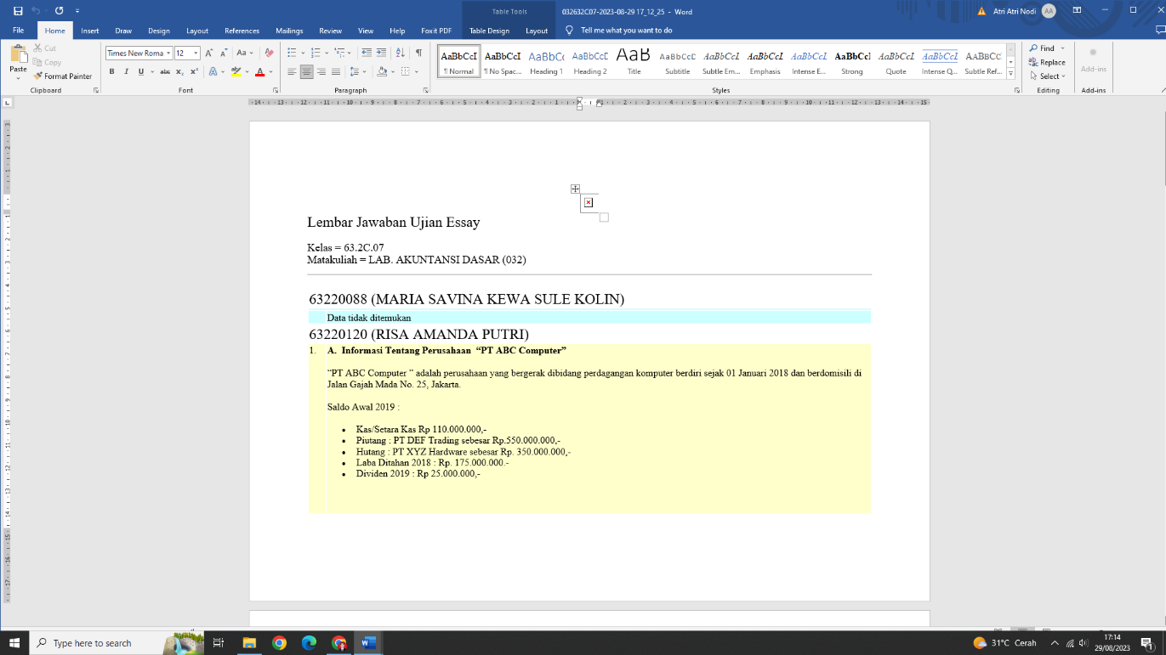

|  |
| --- |
|  |

|  |  |
| --- | --- |
| Nama Dosen | : ATRI NODI MAIZA PUTRA |
| Mata Kuliah | : LAB. AKUNTANSI DASAR [ 032 ] |
| Kelas | : 63.2A.24 |

|  |  |  |  |  |  |
| --- | --- | --- | --- | --- | --- |
| **No.** | **Nim** | **Nama** | Nilai HER | Dosen Penilai | Tanggal Input |
| 46 | 63210663 | WULAN LUSIANA | 0 | SHT | 2022-08-18 08:52:03 |
| 46 | 63220389 | TIVANI RAHMA KANSYAAH |  | TNM | 2023-08-28 14:46:03 |

|  |
| --- |
| Waktu Cetak Tanggal 29-Aug-2023 05:16:19 |

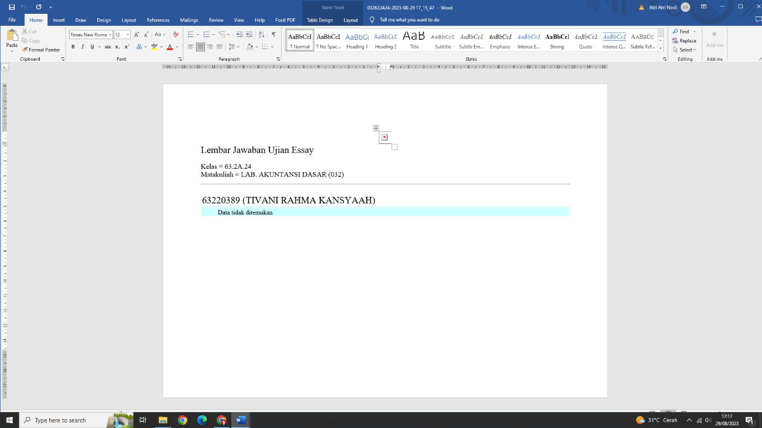

|  |
| --- |
|  |

|  |  |
| --- | --- |
| Nama Dosen | : ATRI NODI MAIZA PUTRA |
| Mata Kuliah | : LAB. AKUNTANSI DASAR [ 032 ] |
| Kelas | : 63.2B.01 |

|  |  |  |  |  |  |
| --- | --- | --- | --- | --- | --- |
| **No.** | **Nim** | **Nama** | Nilai HER | Dosen Penilai | Tanggal Input |
| 47 | 63220763 | NAUVAL SULTAN DZAKY |  | TNM | 2023-08-29 17:19:11 |

|  |
| --- |
| Waktu Cetak Tanggal 29-Aug-2023 05:19:18 |

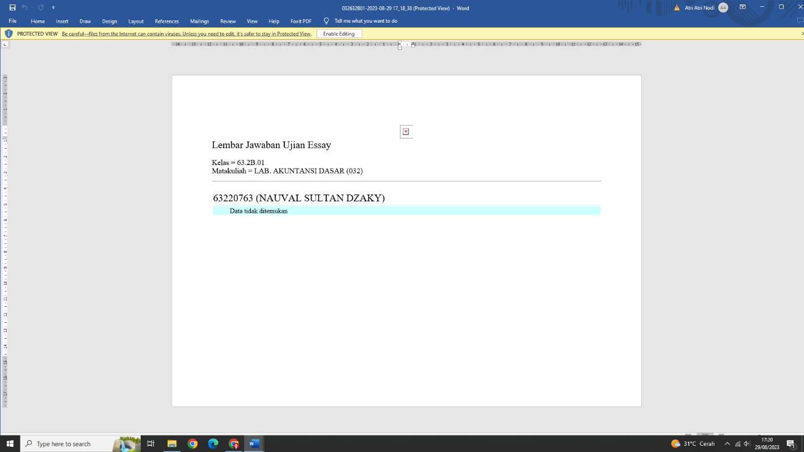

|  |
| --- |
|  |

|  |  |
| --- | --- |
| Nama Dosen | : ATRI NODI MAIZA PUTRA |
| Mata Kuliah | : LAB. AKUNTANSI DASAR [ 032 ] |
| Kelas | : 63.2A.37 |

|  |  |  |  |  |  |
| --- | --- | --- | --- | --- | --- |
| **No.** | **Nim** | **Nama** | Nilai HER | Dosen Penilai | Tanggal Input |
| 48 | 63220798 | ADHA NURSANJAYA |  | TNM | 2023-08-29 17:21:00 |

|  |
| --- |
| Waktu Cetak Tanggal 29-Aug-2023 05:21:14 |

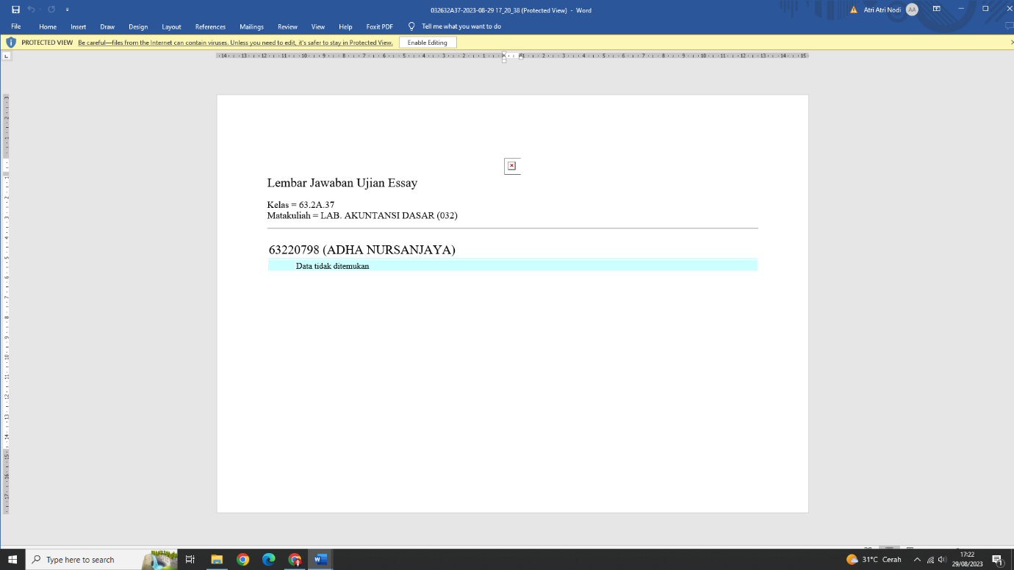

|  |
| --- |
|  |

|  |  |
| --- | --- |
| Nama Dosen | : ATRI NODI MAIZA PUTRA |
| Mata Kuliah | : LAB. AKUNTANSI DASAR [ 032 ] |
| Kelas | : 63.2A.25 |

|  |  |  |  |  |  |
| --- | --- | --- | --- | --- | --- |
| **No.** | **Nim** | **Nama** | Nilai HER | Dosen Penilai | Tanggal Input |
| 49 | 63220899 | MUHAMMAD RIZQI SYABAN POHAN | 70 | DPW | 2023-08-28 20:18:14 |

|  |
| --- |
| Waktu Cetak Tanggal 29-Aug-2023 05:22:44 |