COMPETENCES DEVELOPMENT OF SMALL MEDIUM BUSINESS ACTOR IN UTILIZING INFORMATION AND COMMUNICATION TECHNOLOGY IN BANDUNG AREAS

(CASE STUDY: MSME BUSINESSMEN IN KABUPATEN BANDUNG , WEST JAVA)

¹ YANTI AGUSTINA VERA, ² ARFANI SRI, ³ZUNIARTI IDA ⁴ SETYANINGSIH EKA, ⁵ WINARNO HERI SLAMET
Bina Sarana Informatika University
E-mail: ¹ vera.vay@bsi.ac.id, ²sri.saf@bsi.ac.id,³ida.idz@bsi.ac.id,⁴ eka.edy@bsi.ac.id,⁵ slamet.smh@bsi.ac.id

AbstracT

This research aims to: (1) describe the level of MSMEs bussinesmen competency in the use of ICT in rural areas in Bandung, (2) to analyze the factors that influence the competence of natural businessmen to utilize ICTs for their business activities in rural areas in Bandung, and (3) to formulate strategies for developing competence of MSMEs businessmen, especially in the utilization of ICT in rural areas of Kabupaten Bandung and West Java, Indonesia. Competence in this research is personal competence that is personal ability and skill in effort and technical competence in operational of ICT facilities in every activity of MSMEs businessman. This research was conducted in Kabupaten Bandung from December 2017 to April 2018. The sample of respondents was 313 based on the total population selection of 3033.The data analysis method in this research used Structural Equation Modelling (SEM)-AMOS. Based on the results of this research indicate the perception of MSMEs businessmen and the utilization of ICT facilities have a positive effect on the competence of utilization of ICT facilities, while the level of external environmental support has negative effect but not significant on the competence of MSMEs in utilizing ICT facilities, and the Profile of MSME businessman has positive but not significant.

Keywords: Competence, Small medium enterprise (SME), Information communication and technology (ICT).

- intRoduction
Micro Small Medium Enterprises (MSMEs) is the largest group of economic actors in the Indonesian economy. The Ministry of Cooperatives and Small Medium Enterprises in 2012-2013 shows the development of SME data reached 56,539,560 with 9.5 percent growth. In line with the development, the MSMEs sector faces an increasingly competitive competition, the swift flow of goods coming into the country due to the enactment of an open economy demanded businessmen should be able to face global challenges and adapt to it.
The research results of APEC shows that global environment of SME still has a low competitiveness in Indonesia [1]. Based on APEC SME Innovation Center shows that the indexes score of Indonesian SME competitiveness performance data are in the low category. Products made by business groups at the domestic market level, have not been able to compete with imported goods. This is caused by the quality of goods that are not competitive, and its limited technology.
To support the competitiveness business required the application of information technology in business development. In relation to this research by Tambunan, the data show that Indoesian MSMEs businessmen has a low competitiveness value, only businessmen who have the ability in utilizing information technology that be able to face competition[1]. Nowdays, The ability to utilize information and technology is needed in global challenges. Furthermore, Tambunan argues the companies have implemented information technology in developing of their business will increase the high competitiveness [1].
On the other hand, the ability of businessmen in using ICT is still low. The data from BPS suggests that the low educated MSMEs businessmen is lacking in the mastery of information technology[2]. Based on the survey results of the Daily Tribune News show that the seventeen million MSMEs in Indonesia only 75,000 who have web [3]. Referring to the results of a study by The Asia Foundation (2002), the number of MSMEs utilizing e-commerce in Bandung and Bogor regions was only 18 percent. [4]. According to the daily business of West Java shows that there is still lack capabilities in mastering ICT for MSMEs businessmen[5]. In addition, the facts in the field indicate that there are gaps between conditions in the field and the expected conditions in the use of ICT facilities by business actors in rural and urban areas of West Java province. It requires for awareness of the benefits of technological mastery abilities for the businessmen, in order to enhance sustainable competitiveness.
Increased awareness may arouse people's interest towards in mastery of ICT in order to achieve the optimal ICT competency. One of them through public awareness as an empowerment act, as for the programs of empowerment act through ICT utilization by mentoring small business (SME). It is a step to enhance the capabilities of ICT competence for businessmen [6]. The mastery of information technology for the trade needs to be applied in any business activities. The competence of SME in utilizing the ICT facilities must continue to be improved, along with the growing technological development that is rapidly increasing, as well as the development of internet networks which have an impact on the rise of the information in the digital era.
The importance of the research is to be known by the related parties and government agencies in order they can support to the MSMEs businessmen,and provide of facilities procurement technology tools, policies or regulations, training, mentoring programs which regulate the progress of MSMEs in Indonesia, especially the application of the use of ICT in every business activity. On the other hand, it can be analyzed further related to the obstacles faced by MSMEs businessmen, such as, using of technology implementation and utilization. The another important aspect is the rapidly growing digital era in the business world as well as the digital economic opportunities and behavior of the main consumers in the utilization of technology today is higher especially in using ICT on every business activity.
These conditions encouraged this research aims to (1) assess the level of competence of MSMEs trade in utilizing ICT , (2) analyzes the factors that affect the MSMEs trade competence in utilizing ICT facility,and (3) formulating development strategies of MSMEs trade competence in utilizing ICT facility.

THE COMPETENCE OF MSMEs IN UTILIZATION OF ICT FACILITES
According to Spencer & Spencer, competence is any form of motives, attitudes, skills, behaviour and personal characteristics that are essential to carrying out the work or tell the difference between the average performance with superior performance. Spencer & Spencer adds classify competences into two levels, namely the ability of the threshold and the ability to differentiate. Pary defines competency is a set of knowledge and skills and attitudes relate to one another the effect on individual jobs that correlate with the performance can be improved through training. Furthermore, Government Regulation No. 19/2005 conceptualizes personal competence is competence according to personality and behavior attitude capable of developing potential, according to SANKRI technical competence is the individual ability in a particular technical field for each task[9].
Competence is required not only in business and basic ability of management but also to develop of information and communication technologies. ICT revolution has marked time for information becomes a commodity or power to control it, and the ability of technological competence is essential for improving the quality of products as well as taking opportunities and chances. The role of ICT gives significant benefits to all areas of social, economic and business. On the other hand, the role of ICT support the implementation of knowledge-sharing processes by sharing knowledge through ICT facilities. It use by virtual meetings such as email, mailing list, web conference[10].This study supported by Gaynor argues that the application of the technology in the business on distribution, administrative aspects, the rise of products and manufacturing. Therefore, the mastery of skills in utilization of ICT facilities is required.
The technical competence of the utilization of ICT facilities must be controlled by businessmen currently are as follows (1) a basic level of competency in operating a computer both hardware and software, (2) competency in digital marketing, (3) the competency in using browser to access pricing information, access to information on raw materials and finding business partners, (4) competency in running the application of e-commerce/e-business, and (5) competency in understanding the seven elements of the media literacy . This is becomes important due to the development of internet networks that affect the onset of the revolution of information in the digital age and it has to adapt to the conditions of the digital economy.
.

Research Method
This research was designed as an explanatory research with quantitative approach research which aims to explain the pattern of relationships and influences between variables have done through hypothesis testing. The scope of this research was limited to examine on the relationship profile of MSMEs businessmen, external environment support, MSMEs businessmen perception and utilization of ICT facilities as well as its effect on the competence of MSMEs trade in utilizing ICT facilities. Justification the four sites as the subject of this research is based on the MSMEs that have a diverse range of creative and unique product, having a strategic tourism and area businessmen who have independent business starting with the procurement of raw materials, process and up to the finished product to market and distribute it and capable of utilizing ICT as a facilities of access to information.
The research was carried out in December 2017 to April 2018. The survey was carried out in Kabupaten Bandung, the population of the research in kabupaten Bandung is 3033 with total of craft industry is 345, convection is 1726, and the processed food stuff amount 962. The determination of the total sample is using Slovins formula with 5 % of standard errors. The number of samples people, Kabupaten Bandung consist of 313 people.

Framework and Hypothesis
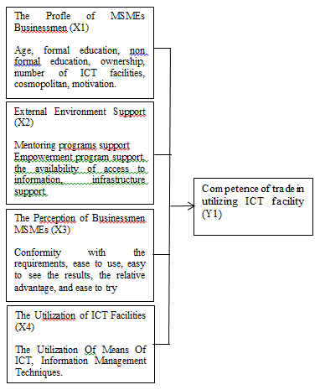
Figure 1. Relationships between variables and the competence of the MSMEs businessmen utilizing ICT
Based on the framework, research hypothesis used as follows: MSMEs trade level of competence in Kabupaten Bandung in the utilization of ICT facilities which are influenced significantly by the businessmen's profile effort (X1), external environment support (X2), the perception of MSMEs businessmen (X3), and the utilization of ICT facilities (X4).

- result and discusion
5.1 Utilization rate of ICT Facilities by MSMEs Businessmen

Each individual MSMEs businessmen have different characteristics in using and utilizing ICT facilities. Characteristics of the businessmen efforts in utilizing ICT facilities is the reflection of businessmen in operating ICT facilities in each of its business activity. The description of the characteristics of MSMEs businessmen in utilizing the facilities of ICT are hardware and software. It presented in Figure 2.
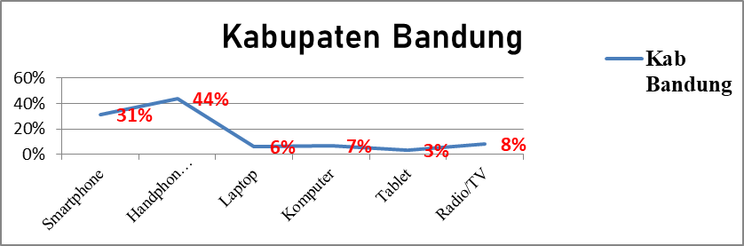
Figure 2. Utilization rate of ICT facilities

People use of mobile phones is higher category than people use of other ICT facilities among MSME actors in Bandung, especially people use of mobile phones based on conventional applications without complete feature. The result of this research show that the people used of ICT facility applications of Android-based tab is categorized lowest in the utilization of ICT.

5.2. Profile of MSMEs Businessmen in Utilizing ICT Facilities

Profile of MSMEs businessmen based on composition in Kabupaten Bandung is the highest Amount 74 % of the businessmen. it is categorized productive adulthood about (20-46 years). It can be seen on table 1. The level of formal education of MSMEs businessmen mostly attended to secondary schools (junior-senior high school). The average number of ownership of ICT facilities 1-6 units of ICT equipment is categorized of low, and the period of ownership of ICT facilities is during 1-11 years. it caused of low intensity of counseling and training from the Government related to the use of ICT facility applications in business activities, which is the highest in the rare category. (3). The Cosmopolitan level is categorized as low amount 61.7%. The motivation level is in the medium category amount to 44.9%. This study supported by Batte et al research (1990) shows that the level of application of Information and Communication Technology is closely related to age and education factors with average duration ranges ≥ 12 years. Non formal education category owned by the businessmen mostly &gt; 80 percent. It means rare level, the training frequency &lt; 3 can be seen in table 1. The data shows that the low intensity of counseling or mentoring which related Government in using ICT facilities application in business activities. Research results showed that the level of implementation of information and communication technologies greatly associated with age and education factors[15].
On the other hand, Rukia states that the motivation is the impulse of arises from one's self to a direction of behavior. It begins to need of causes encouragement. The motivation level of MSMEs businessmen in the four research sites is mostly in medium category, since the highest average category for business actors is only using cellular means; the utilization of using the computer for business activities is low. This is supported by field data shows the MSMEs bussinesmen in rural and urban are interested in using ICT cellular facilities caused by ease and speed in transacting.

Table 1. Descriptive Profile of SME Bussinessmen in Utilization of ICT Facilities

Sub Peubah | Kategori | Kab. Bandung(%)  n=313
Usia (tahun) | Remaja(<20) | 0.0
 | Dewasa(20-46) | 74.1
 | Lanjut usia >47 | 25.9
Pendidikan Formal | Dasar(0-6) | 20.9
(tahun) | Menengah(9-12) | 18.7
 | Lanjut >12 | 60.4
Pendidikan Non | Jarang (<3) | 94.6
Formal (frek/tahun) | Sedang(3-5) | 3.8
 | Sering(>5) | 1.6
Lama kepemilikan | Sangat lama (>16) | 0
Sarana TIK (tahun) | Cukup lama(12-16) | 0
 | Lama (1-11) | 100
Jumlah kepemilikan | Rendah (1-6) | 100
Sarana TIK (unit) | Sedang (12-16) | 0
 | Tinggi (17) | 0
Kosmopolitan | Rendah | 61.7
(skor) | Sedang | 24.7
 | Tinggi | 13.6
Tingkat Motivasi | Rendah | 36.4
(skor) | Sedang | 44.9
 | Tinggi | 18.7
Source : data processed in 2017

This result is different from the results of research conducted by Kim et al. (2011) and Muliady (2000) that state the motivation to use ICT is only due to attention and interest in the world of IT and supported by high skill in using ICT .

5.3 External Environmental Support, Perceptions of MSMEs Businessmen in Utilization of ICT Facilities
External environment Support on the level of quality support mentoring and support programs empowering businessmen in utilizing ICT belongs to the moderate category, businessmen of Kota Bandung have the highest percentage of 80 percent and 70 percent for the level of support of empowerment.
Based on the results of field research shows the intensity of extension related to ICT knowledge and application in business world. The rate is low in one year and <5 times the counseling frequency. The materials and extension methods connected the use of ICT have been submitted is online marketing through internet. The use of basic applications of computerized finance, which is support of empowerment programs in the form of facilitation of learning and procurement of ICT facilities for business actors. They have groups or joined together with the business community to receive priority support or assistance from the government. The access of information and availability of adequate infrastructure network have good enough in four research areas in Kabupaten Bandung, ICT facilities to access of information in urban and rural areas in Kabupaten is sufficient as indicated by the percentage of scores on average > 80 percent. The infrastructure network in the four research areas is also sufficiently available in the physical facilities of the building, transmitter towers, road facilities, and other physical facilities.
The level of perception of MSMEs businessmen toward the characteristics of ICT innovation is high average, the perception of business actor needs and ease to use of ICT facilities both businessmen in urban and rural areas in Bandung , as indicated by the average Likert scale 3.97 categorized as high level. The level of business actors' perceptions are benefits of medium-sized ICT facilities with an average value of 2.5, ease of viewing results with a value of 2.4 and ease of use with a value of 2.3.
Based on the results of study, the people of SME business community has an assessment nowadays, and the utilization of ICT facilities is required for business actors in each business activity. Business actors can assess their mobile cell phone, internet, computer with others. In addition, other ICT facilities have been used by businessmen is suitable for all business activities such as marketing communications and accelerate customer service customers. Regarding to the research above, there is research by Gaynor’s show that the application of technology is widely utilized in the business world in aspects (1) distribution, (2) marketing, (3) administration, (4) product awakening, (5) manufacturing[11].
The results of field observations show that the terms of the level utilization of ICT facilities both computer and mobile facilities MSMEs at urban is higher than the Kabupaten. It can be shown on the intensity score of the utilization rate and the management of ICT facilities of MSMEs businessmen of Kota Bogor by 60 percent. Then, the information management level of MSMEs businessmen in Bandung 70 percent. The field observations data show that its caused by the educational level of MSMEs businessmen in urban area is higher than businessmen in Kabupaten, so the level of awareness, assessment of the use and benefit of ICT is higher, whereas the utilization of ICT facilities level include of ICT information management on the businesman in the Kabupaten is moderate. Relate to this study above, there is Research results by Kemenkoinfo shows that people’s understanding and satisfaction in utilization of ICT is not optimal than the urban community[19]. Based on Observation of field researcher that most of MSMEs businessmen in Kabupaten do not routine to use computer facilities in every their business activity. Moreover, for cellular facilities in using ICT facilities such as Handphone with frequency of use it is > 10 times in one week. It is relating with Hafsah research shows that the higher intensity of ICT utilization facilities influenced by the high competence of businessmen in applying ICT facilities [20]. Based on the result of field observations show that the average level of information management belongs to the MSMEs businessmen in the urban demographic of the population such as consumers have high mobility level on the use of ICT, and the urban community tend to cosmopolite, so that the impact of most consumers of SMEs in urban areas tend to be very high in the management of information on ICT facilities.Thus encouraging businessmen to actively use a variety of applications mobile facilities and computers either choose information, manage, and disseminate information. Suaib research results shows the ability to process data with basic processing into an information can be done more efficiently by using computer. Based on field observations show that the application such as Whats App, Blackberry, SMS application are dominant application used by businessmen, and they usually use their conventional Handphone, beside that, the social media application used by some respondents in the Kabupaten to interact with customers[21].

5.4 Personal Competence and Technical Competence of MSMEs Businessmen
Competence of ICT utilization is very important in the era of gitalitasasi because currently there is a shift from offline to digital or online economy. The importance of ICT control optimally in its utilization among business actors. The results of the previous research Eye et. al. and Aang research indicate that the skills of ICT use through the process of facilitation for MSMEs during ICT learning process is quite important[6][22].
The results of field observations showed that the level of personal competence of MSMEs businessmen in the urban areas and in the Kabupaten have high category with a percentage score > 70 percent. This shows the personal ability of MSMEs businessmen who have a persistent fighting spirit and high motivation spirit and have responsibility in the business activity pertained good. The technical competence rate of businessmen in the four areas of this research have moderate categorized with a percentage score > 75 percent. Because businessmen in Kabupaten Bandung have limitations in utilizing ICT facilities with a variety of software applications such as computer facilities and Handphone. On average, the MSMEs businessmen only have ability to use of cellular to communicate and manage information that is downloading images and copying images through Handphone media with certain applications. From field observations only Whats App applications and blackbery applications that can be mastered in managing information, while the computer very rarely used by businessmen in Bandung, cause it is not easy to carry anywhere.
Regarding to study above, there is research by Sree Devi show that female businessmen in India succeed in the sustainability of their business. They can exploiting the potential of ICT[23]. Female businessmen increase in mastery of using ICT facilities, They was trying to follow the skills of managing information and data by the facilities of computers. They also starting the process of data entry and managing data. The other research was done by Rifki’ shows that indicate the skills or competence of ICT facilities should be controlled by MSMEs businessmen because skills the current managerial business must be integrated with the use of information systems on ICT in any business activity, such as they use for marketing or product promotion, communicating and transaction via online with customers and business partners[24]. Based on the results of the previous research above, it can be concluded that the sustainability of MSMEs businessmen can be achieved through the acquisition of ICT technolog. It is necessary to assist the process for the successful application of ICT in business activities. However, the results of field observations describes that the average of MSMEs businessmen in the West Java Province currently has not optimal for competence in the mastery of various applications of ICT because of the low level of assistance and support intensity empowerment program related to the utilization of ICT facilities. It can be seen by the level of intensity of mentoring still less than <5.

  - Fulfillment of Assumptions, Validity and Reliability

This study used SEM assumptions for checking the normality level of the data. This testing was done by observing the value of skewness of the data used. if the CR value of skewness data is in the range of 2.58 with a significant level of 0.05 (Latan,2013), then the results of data processing there is no CR value for skewness which is outside 2.58. The research data used has meted the terms of -1,483 normality or can be said that the research data has been distributed normally.
It means the reliability test shows that the cronbach alpha value of each construct shows a good result of the cronbach alpha coefficient obtained largely to meet with the required by Tomb Rules which is 0.7. The internal consistency testing of cronbach alpha needs to be done with instrument reliability test with contruct validity and extracted variance which obtained mostly shows value above 0.5. This means that all reliable instruments that is Y1 = Competence indicates that the value of the MSMEs bussinesmen variable in Bandung both technical and personal competence in utilizing ICT is quite reliable.

  - Analysis of Factors that Influences the Competence of MSMEs Businessmen
Factors affecting businessmen competence in utilizing ICT facilities are analyzed by SEM presented in Figure 3.
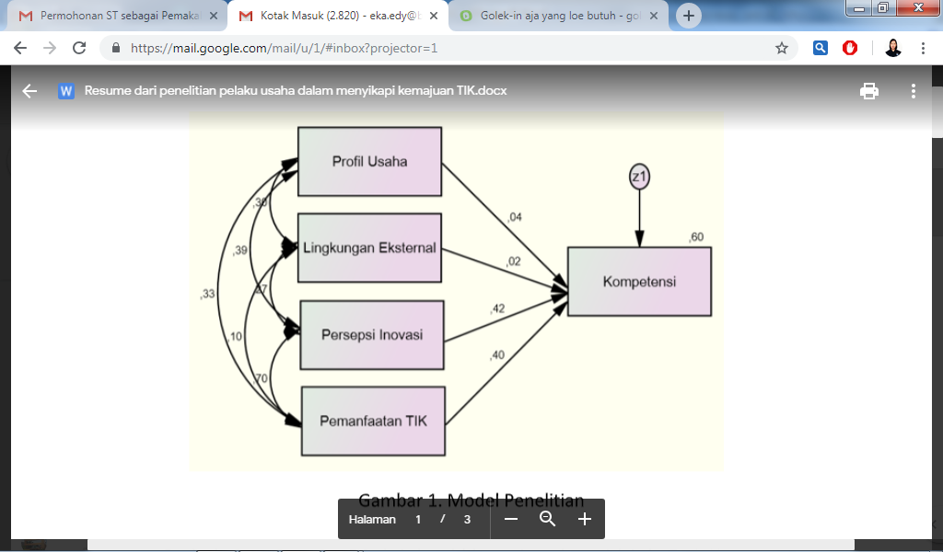

Figure 3 Estimation of Structural Model Parameters

Based on the results of hypothesis that (1) testing and the level of probability of the causal relationship of hypotheses between factors sub variable X1-X4 against Y1. Variable (X1) profile of MSME business actors positively influences competency coefficient 0.04 is positively related to competence but it is not significant amount 0.071; (2) the external environment support has a negative and insignificant effect on the competence of business actors in utilizing ICT facilities by 0.02, (3) the perception variable of business actors (X3) on competence has a positive effect of 0.42; and variable (X4) of 0.40 the level of utilization of ICT facilities has a positive effect on the competence of MSME business actors. Through the Determination Value significance test R2 shows the competency level of the business actor as much as 60.3% is influenced by perceptions of the business actor and the level of utilization of ICT, while 39.7% of the competency of the business actor is influenced by other factors not included in this study.

Table 2. Decomposition of influence between profiles of SME business actors, external environmental support, perceptions, utilization of ICT facilities, competence and business sustainability

Hubungan antar peubah | Nilai koefisien pengaruh | Nilai prob
 | Langsung
X1 Y1 | 0.04 | 0.276
X2 Y1 | 0.02 | 0.000
X3 Y1 | 0.40. | 0.639
X4 Y1 | 0.43 | 0.000

  - Factors Affecting the Competence of MSMEs businessmen in Utilizing ICT Facilities in Bandung
Based on the standardized loading factor (λ), it is known that the 5 percent sign level of 0.05 factors that influence of competency of MSME business actors. The factors are: the profile of business actors, perceptions of MSME business actors, use of ICT facilities. This analysis use of models obtained by confirmatory factor analysis CFA and supported by predictor indicators. It declared valid and can be used to measure latent variables, it can be seen in figure 3 shows that the competency of business actors more influenced dominantly by the use of ICT facilities, and It is followed by the magnitude of the influence of perception. This is in line with the research by Fatmariani (2012) suggesting that the intensity of the use of ICTs affects the ability of individuals to use ICT. The positive influence shows that the higher the competence of MSME business actors, the higher the level of utilization of ICT facilities and the level of information management. The profile of MSME business actors will significantly affect the competence of MSME business actors. Therefore, the higher the motivation of business people, the more influences the competence of MSME business actors.
This research supported by Hubeis research (2011) show that individual competency factors are influenced by the education process. MSMEs on the characteristics of ICT innovations have a significant influence in increasing the competence of MSME business actors. The higher influence of perceptions in MSME business actors on the characteristics of ICTs in improving competence, the higher perceptions will show the higher understanding of business actors on ICT characteristics. The perceptual supporting factor variables can be explained by perceptual indicators, and then the supporting factors of perceived ease of use are the strongest indicators in reflecting the perceptions of business actors on ICT innovation characteristics. It is followed by perceptions of relative benefits, then perceptions of ease of seeing results and perceptions of suitability and, it is needs easy to try. This implies to the perception of ease use and the perception of profit is relatively more dominant in forming supporting factor variables, namely MSME business actors towards the characteristics of ICT innovations and the affect the competence of MSME business actors in utilizing ICT facilities. This is in line with the research of Heilman et al. (2009) show that the perception process is closely related to the competence of business actors in utilizing ICT facilities among small businesses.
The variables supporting the use of ICT facilities are able to be explained in the indicators of the level of ICT facilities for the level of information management. This means that the level of information management is more dominant in shaping supporting factors, namely the use of ICT facilities can be influence the level of competence of MSME business actors in utilizing ICT facilities. The results of Audita (2011) show that the use of ICT affects the competence of businesses in utilizing ICT facilities. It can be seen in Figure 3 shows that the three indicators explain the level of competency of MSME business actors influence of each variable, and 3 variables greater than the standard standard> 0.07 and positive. This means that the profile level of MSME business actors, the level of perception and level of utilization of ICT facilities have a positive influence on the competency of MSME business actors in utilizing ICT facilities. One variable, namely the support of the external environment does not affect the competence of MSME business actors in utilizing ICT. Based on data shows that the external environment which has support in field does not effect of competency, because high competency is not necessarily a high level of external environment support, because the results of interviews and observations in the field show the low level of competency of MSME entrepreneurs using ICT, but the business continues because it has had a market access network since hereditary, their dominant business comes from family inheritance, the ability of business people to obtain business from generation to generation, and raw materials are easily obtained, and have regular customers.

  - Strategy of Competence Development of MSMEs Businessmen in Utilizing ICT Facilities
Based on the result of SEM analysis in Figure 3, the formulation of strategy to increase the competence of MSMEs businessmen in utilizing ICT facilities. It were done with two strategies, first strategy is the development of the first stage competence to increase the intensity of the utilization of ICT facilities such as conducting intensive training programs through ongoing assistance, it can be done by collaborating with business community groups. Related to this, it is necessary to carry out continuous and systematic assistance and counseling, through appropriate mentoring methods, training materials tailored to the needs of businessmen, establish cooperation with higher education institutions and the availability of professional assistants in ICT field. The second strategy is to increase competence through the strengthening of perception, in this case improve the understanding of business actors related to the important role of ICT in business activities. The following strategy for developing competencies of MSME business actors in utilizing ICT facilities using input, process and output strategies is presented in Figure 4.
First stage competence development starts from profiding (1) encouraging and increasing

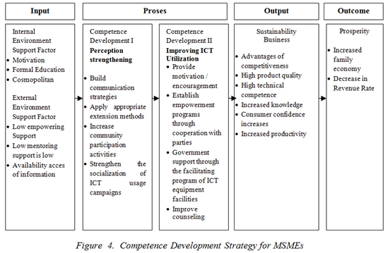
motivation of business group; (2) strengthening perceptions on business actors so that they have an awareness of the importance in using ICT facilities; (3) reinforcement on the attitude of business actors to use of ICT facilities; (4) aware the intensity of daily use of ICT, and to give intensive training in using of ICT based on instructions; (5) providing facilities tools for extension
Figure 4. Competence Development Strategy for MSMEs

facilities for business actors; 6. Providing assistance with training facilities is supported by an appropriate mentoring method program in accordance with the extension program as needed. In addition, it provides encouragement, capital support for the procurement of equipment or business capital and support of empowerment programs with the availability of access to information and ICT infrastructure.
The next stage is the development of business entrepreneur strengthening competence in the business community groups in raising the spirit and increasing participation to use ICT facilities, the availability of learning facilities, and strengthening the group, strengthening cooperation with private parties and universities and strengthening the campaign movement to increase awareness of the importance of the use of facilities ICT.

- Conclution and suggestions
- The level of competence of MSMEs businessmen in utilizing ICT facilities including the personal competency is categorized high level, and personal technical competency is categorized of average in Kabupaten Bandung,
- The profile of MSMEs businessmen, the perception of MSMEs businessmen and the utilization of ICT facilities have an effect on the competence of MSMEs businessmen in utilizing ICT facilities, and the factor of the utilization of ICT facilities is the dominant factor influencing business entrepreneur competence in utilizing ICT facilities, the external environment support has no effect.
- Increasing the competence of MSMEs businessmen in utilizing ICT facilities is carried out by strategy: (1) improvement of ICT utilization through intensive program of counseling and mentoring as well as training related to the use of ICT facilities, (2) strengthening perception of the benefits of ICT use in business community groups

INOVATION AND CONTRIBUTION
The research contribution are :
- Provide a general description of mapping the ability for businessmen in using technology, in order the Government can create policies that support for MSMEs businessmen in mastering or use of ICT.
- Improving the ability of businessmen in utilizing the technology facilities, especially in developing a variety of software applications and hardware usage for MSMEs businessmen.

Technological inovation provided:
- For businessmen : The businessmen can effort to get appropriate counseling and accompaniment for innovative and creative learning relate with it for developing competence of MSMEs businessmen in utilizing ICT facilities.

REFERENCE:
[1] Tambunan T. “Usaha Kecil dan Menengah di Indonesia”. Jakarta [ID], Salemba Empat. 2013.
[2] BPS. Badan Pusat Statistik. “Survei Kebutuhan bahan bakar Minyak”, Jakarta. 2006.
[3] Tribunnews. Jumlah Pengguna Internet Indonesia.[internet] [Diunduh 8 Agustus 2012].Tersedia pada :[http://wartakota.tribunnews.com/index-news]. 2012.
[4] The Asian Foundation – Castle Asia.2002.SMES and E-Commerce in foundation.
[5] Daily Business of West Java the year 2013
[6] MataF, W. Fuerst, J. Barney. “Information Technology and SustainedCompetitive Advantage: A Resource-Based Analysis”. 1995.
[7] Spencer Lyle M, Signe M.Spencer. “Competence Work: Model For Superior Perfomance”, O. John Wiley and Sons, In. 1993.
[8] Soemardjo. 2008. Perlukah Standarisasi Kompetensi. Makalah disajikan dalam Seminar Pemberdayaan Masyarakat Fakultas Ekologi Manusia IPB, 7 Juli 2008.
[9] SANKRI Sistem Administrasi Negara Republik Indonesia. 2003 [Internet ].[diunduh 2015 Januari 15].Tersedia pada :[http;//bkd. Jabar. Prov]
[10] Soemardjo et al. “Cyber ExtentionPeluang dan Tantangan dalam revitalisasi Penyuluhan” . Bogor [ID]:IPB Press. 2009.
[11] Gaynor, GH. “Achieving The Competitive Integrated TechnologyManagement”. New York: Mc Graw Hill. 1991.
[12] Diamond 2015 The visual Marketing Revolution, Jakarta [ID].serambi alam semesta
[13] Aang A. “Mengenal E Commerce. Jakarta” :[ID] PT.Elex Media Komputindo, 2001.
[14]BALITBANG DEPKOMINFO Badan Penelitian dan Pengembangan Departemen Komunikasi dan Informasi . 2007.
[15] Batte MT, Jones E and Schnitkey GD. “Computer Use by Ohio Commercial Farmers”. American Journal og Agricultural Economics. 72;935-945. 1990.
[16] Rukia. “Hubungan karakteristik penyuluh dengan kinerja penyuluh pertanian di Kabupaten Simalungun”. Jurnal Agrica Extention (10) (2):35-44. 2016.
[17]Muliady. “Faktor-faktor yang Mempengaruhi Kinerja Penyuluh Pertanian”. [Disertasi]. Bogor: Institut Pertanian Bogor. 2009.
[18] Lee Y, Kim S, Lee H. “The Impactof service R&D on the performance of Korean Information Communication Technology small and Medium enterprise”. Journal of Engineering and Technology Management . 2011.
[19]KEMENKOINFO. “Data Pengguna Teknologi Informasi”. Hasil survey TIK. Jakarta [ID]: Depkominfo. 2012.
[20] Hafsah MJ. Pemberdayaan Potensi Bisnis dan Agroindustri. Makalah Seminar disampaikan Universitas Terbuka, Pondok Cabe, 21 Oktober 2003. 2003.
[21] Suaib. “Pengaruh Lingkungan, Perilaku, Struktur Organisasi, dan Implementasi Sistem Informasi Berbasis Komputer”. Jurnal Cakrawala, 15(2); 36-45. 2013.
[22] Aang A. “Mengenal E Commerce”. Jakarta:[ID] PT.Elex Media Komputindo. 2011.
[23] Sree Devi. “Economic Empowerment Through information technology: case study from Indian State”. Journal of International Womens Studies, 2007, 8(4):107-120. 2007.
[24] Rifki M. “Analisis Tingkat penggunaan teknologi informasi dan komunikasi pada usaha kecil menengah Kabupaten Jepara”. Jurnal Dinamika Ekonomi dan Bisnis. 9 (2);75-74. 2012.
[25] Bentler & Chou (1987).Pratical Issues in Structural Modelling Sociological Method and Research.
[26] Hair et.al. 1998. Multivariate data Analysis . Fith Edition . New Jersey[USA]Prentice Hall , Upper Sadle River
[27] Fatmariani. “Pengaruh adopsi teknologi informasi”. Jurnal Teknometika 1(1):243-253. 2011.
[28] Hubeis M. “Menuju Industri Kecil Profesional di Era Globalisasi”. Orasi ilmiah Guru Besar Ilmu Management Industri. Bogor [ID]. IPB Press.2011.
[29] Heilman et al. “Validating The Study”, Proc. 10 th Australian Conference. 2009.
[30] Audita. “Analisa Pemanfaatan TIK”. Jurnal Siasat Bisnis 16(2): 47-50. 2012.

