Lampiran A-01
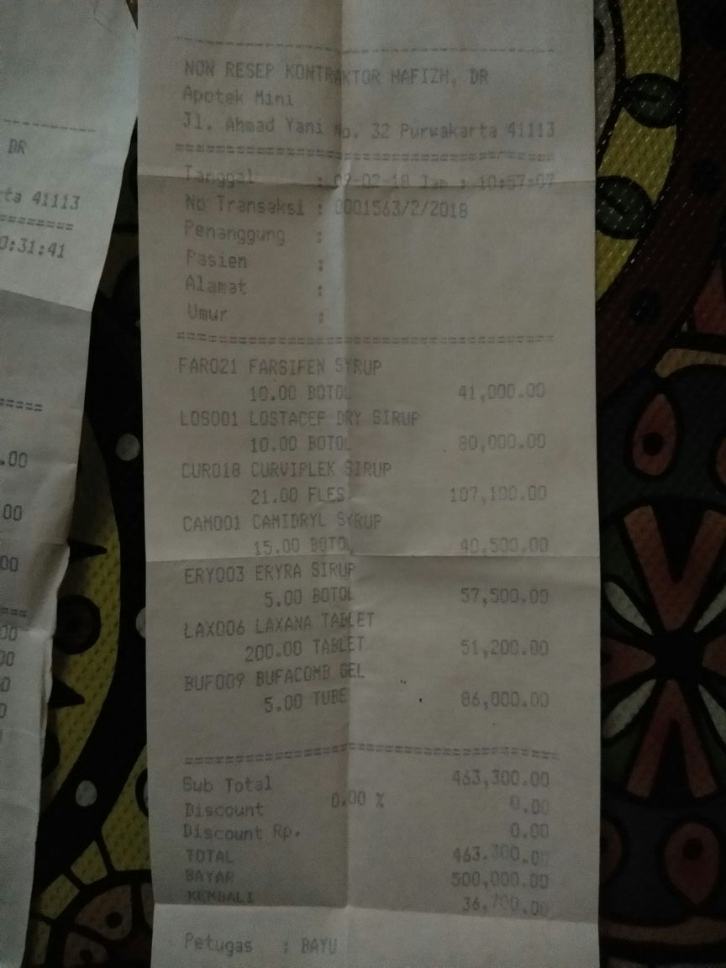

Lampiran B-01
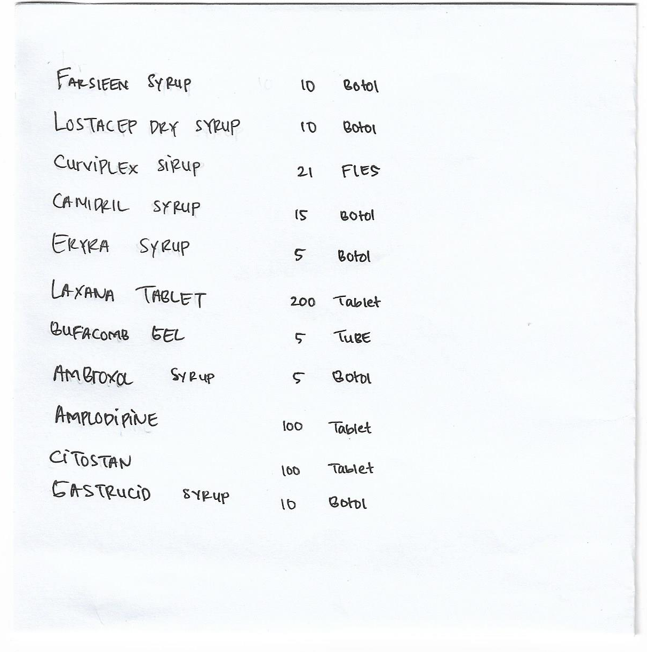

Lampiran C-01
Distributor Obat Non Resep Apotek Mini Petugas : Rizky
Jl. Ahmad Yani No.32 Purwakareta 41113
Tanggal : 14/07/2018
No Transaksi : 0001563/7/2018
No | Kode Barang | Nama Barang | Unit | Harga Satuan | Jumlah
1 | FAR021 | FARSIFEN SIRUP | 10 Botol | 4,100.00 | 41,000.00
2 | ERY003 | ERYRA SIRUP | 5 Botol | 11,500.00 | 57,500.00
3 | CAM001 | CAMIDRYL SIRUP | 15 Botol | 10,000.00 | 150,000.00
4 | LAX006 | LAXANA TABLET | 200 Tablet | 2,560.00 | 51,200.00
5 | OBH001 | OBH LUCAS SIRUP | 15 Botol | 8,000.00 | 120,000.00
6 | BUF009 | BUFACOMB GEL | 5 Tube | 17,200.00 | 86,000.00
7 | CUR018 | CURVIPLEX SIRUP | 21 Fles | 5,100.00 | 107,100.00

Sub Total : 612,800.00
Discount Rp. : 800.00
Total : 612,000.00
Bayar : 612,000.00
Kembali : 0

Lampiran C-02
KLINIK NAURA MEDIKA
Kp. Cinta Karya RT/RW 012/005 No. 32 Desa Cikopo
Kec. Bungursari Kab. Purwakarta
Telp: 081252222101 - 087700099222
Puwakarta, 28 Juli 2018

dr : dr. Rizki
Pro : Ny Anisa
Umur : 21 Tahun

R/
Amoxillin 200 mg No. XII
S. 3 dd 1
R/ Ibuprofen tab no X S. 1 dd tab 1
Paracetamol mg 120

Lampiran D-01

KLINIK NAURA MEDIKA
Kp. Cinta Karya RT/RW 012/005 No. 32 Desa Cikopo Kec. Bungursari
Kab. Purwakarta Telp:0812 5222 2101-0877 0009 9222
Purwakarta 41181



==================================================================================

Bulan : Juli Tahun : 2018

No Terima | Tanggal Masuk | Kode Obat | Nama Obat | Harga | Jumlah
0001563 | 14/07/2018 | FAR021 | FARSIFEN SIRUP | 4,100.00 | 41,000.00
0001563 | 14/07/2018 | ERY003 | ERYRA SIRUP | 11,500.00 | 57,500.00
0001563 | 14/07/2018 | CAM001 | CAMIDRYL SIRUP | 10,000.00 | 150,000.00
0001563 | 14/07/2018 | LAX006 | LAXANA TABLET | 2,560.00 | 51,200.00
0001563 | 14/07/2018 | OBH001 | OBH LUCAS SIRUP | 8,000.00 | 120,000.00
0001563 | 14/07/2018 | BUF009 | BUFACOMB GEL | 17,200.00 | 86,000.00
0001563 | 14/07/2018 | CUR018 | CURVIPLEX SIRUP | 5,100.00 | 107,100.00
0001574 | 21/07/2018 | YUMAX01 | YUSIMOX SIRUP | 12.500 | 125.000
0001574 | 21/07/2018 | HCO003 | HICO GEL | 20.000 | 100.000
0001574 | 21/07/2018 | ERLM112 | ERLAMICETIN TETES MATA | 17.000 | 85.000
0001574 | 21/07/2018 | BRON23 | BRONCHITIS SYR | 14.000 | 70.000
0001574 | 21/07/2018 | AFB11 | AFIBRAMOL | 12.000 | 60.000
0001574 | 21/07/2018 | CTZ011 | CETERIZIN SYR/TRISELA | 13.000 | 65.000
0001574 | 21/07/2018 | LOC012 | LOCTACEF | 18.000 | 90.000
 |  |  |  | Total : | 1.207.800.00

Lampiran D-02

KLINIK NAURA MEDIKA
Kp. Cinta Karya RT/RW 012/005 No. 32 Desa Cikopo Kec. Bungursari
Kab. Purwakarta Telp:0812 5222 2101-0877 0009 9222
Purwakarta 41181

==================================================================================

Bulan : Juli Tahun : 2018

No Keluar | Tanggal Keluar | Kode Obat | Nama Obat | Harga | Jumlah
0001400 | 14/07/2018 | FAR021 | FARSIFEN SIRUP | 4,100.00 | 41,000.00
0001502 | 15/07/2018 | ERY003 | ERYRA SIRUP | 11,500.00 | 57,500.00
0001600 | 16/07/2018 | CAM001 | CAMIDRYL SIRUP | 10,000.00 | 150,000.00
0001701 | 17/07/2018 | LAX006 | LAXANA TABLET | 2,560.00 | 51,200.00
0001702 | 17/07/2018 | OBH001 | OBH LUCAS SIRUP | 8,000.00 | 120,000.00
0001811 | 18/07/2018 | BUF009 | BUFACOMB GEL | 17,200.00 | 86,000.00
0001812 | 18/07/2018 | CUR018 | CURVIPLEX SIRUP | 5,100.00 | 107,100.00
0002100 | 21/07/2018 | YUMAX01 | YUSIMOX SIRUP | 12.500 | 125.000
0002321 | 23/07/2018 | HCO003 | HICO GEL | 20.000 | 100.000
0002322 | 23/07/2018 | ERLM112 | ERLAMICETIN TETES MATA | 17.000 | 85.000
0002404 | 24/07/2018 | BRON23 | BRONCHITIS SYR | 14.000 | 70.000
0002505 | 25/07/2018 | AFB11 | AFIBRAMOL | 12.000 | 60.000
0002707 | 27/07/2018 | CTZ011 | CETERIZIN SYR/TRISELA | 13.000 | 65.000
0002808 | 28/07/2018 | LOC012 | LOCTACEF | 18.000 | 90.000
 |  |  |  | Total : | 1.207.800.00

Lampiran D-03
No Keluar | No Resep | Nama Obat | Harga | Jumlah | Subtotal
0001400 | 000001 | FARSIFEN SIRUP | 4,100.00 | 10 Botol | 41,000.00
0001502 | 000002 | ERYRA SIRUP | 11,500.00 | 5 Botol | 57,500.00
0001600 | 000003 | CAMIDRYL SIRUP | 10,000.00 | 15 Botol | 150,000.00
0001701 | 000004 | LAXANA TABLET | 2,560.00 | 200 Tablet | 51,200.00
0001702 | 000005 | OBH LUCAS SIRUP | 8,000.00 | 15 Botol | 120,000.00
0001811 | 000006 | BUFACOMB GEL | 17,200.00 | 5 Tube | 86,000.00
0001812 | 000007 | CURVIPLEX SIRUP | 5,100.00 | 21 Fles | 107,100.00
0002100 | 000008 | YUSIMOX SIRUP | 12.500 | 10 Botol | 125.000
0002321 | 000009 | HICO GEL | 20.000 | 5 Tube | 100.000
0002322 | 000010 | ERLAMICETIN TETES MATA | 17.000 | 5 Tube | 85.000
0002404 | 000011 | BRONCHITIS SYR | 14.000 | 5 Botol | 70.000
0002505 | 000012 | AFIBRAMOL | 12.000 | 5 Botol | 60.000
0002707 | 000013 | CETERIZIN SYR/TRISELA | 13.000 | 5 Botol | 65.000
0002808 | 000014 | LOCTACEF | 18.000 | 5 Botol | 90.000
 |  |  |  | Total : | 1.207.800.00
KLINIK NAURA MEDIKA
Kp. Cinta Karya RT/RW 012/005 No. 32 Desa Cikopo Kec. Bungursari
Kab. Purwakarta Telp:0812 5222 2101-0877 0009 9222
Purwakarta 41181

==================================================================================

Bulan : Juli Tahun : 2018

Lampiran D-04
KLINIK NAURA MEDIKA
Kp. Cinta Karya RT/RW 012/005 No. 32 Desa Cikopo Kec. Bungursari
Kab. Purwakarta Telp:0812 5222 2101-0877 0009 9222
Purwakarta 41181
Tanggal : 28 Juli 2018
No Resep : 000001
Dokter : dr. Rizki
Nama Pasien : Anisa
--------------------------------------------------------------------------------------------
Amoxillin
12 tab 15,600

Ibuprofen
12 tab 14,400

Paracetamol
1 botol 15,000
Js Dokter
--------------------------------------------------------------------------------------------
Total 70,000
-------------------------------------------------------------------------------------------
Terima Kasih Atas Kunjungan Anda Semoga Lekas Sembuh

