    - Rancangan Basis Data
- ERD

1 1
1 1
1 1 1
1
1
1Q
M

1 1

M M 1

Gambar lll.17

Entity Relationship Diagram
- LRS (Logical Record Structure)

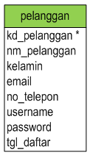
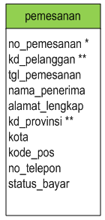
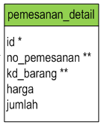
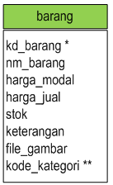

1 1 1 1 M 1

1 M

1

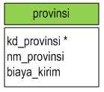
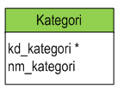
1 1

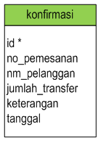
1

Gambar III.18

Logical Record Structure

