LAMPIRAN-LAMPIRAN
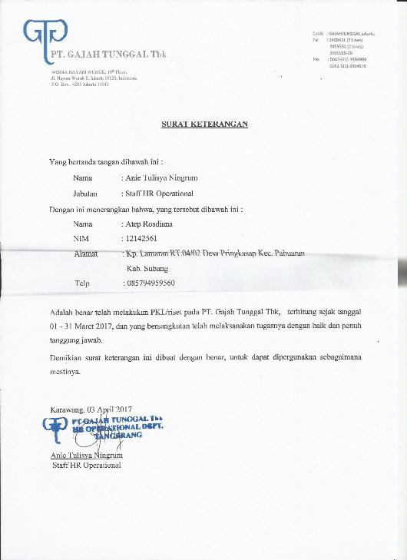
Lampiran A.1. Surat Keterangan Riset (PKL)

Lampiran A.2. Form On Vehicle Tire Test OVT
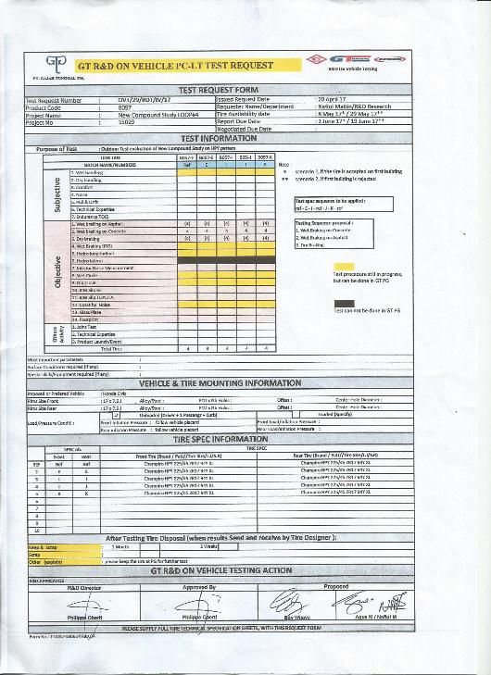

Lampiran A.3. Form Proving Ground Job Order
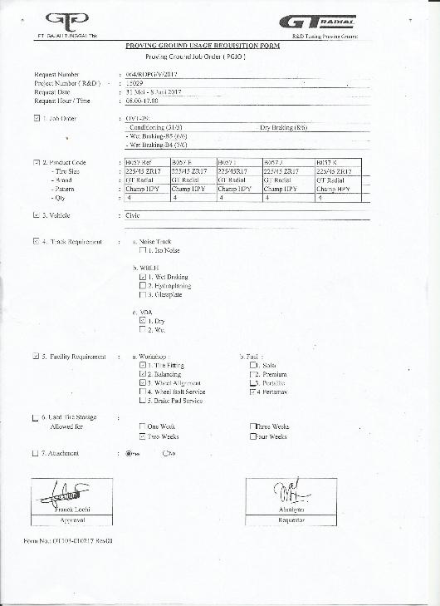

Lampiran B.1. Tampilan Menu Index
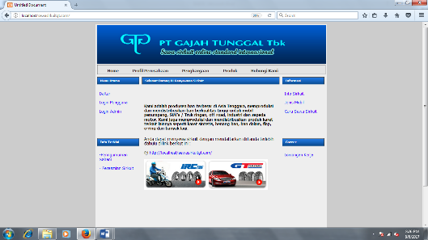

Lampiran B.2. Tampilan Menu Pendaftaran
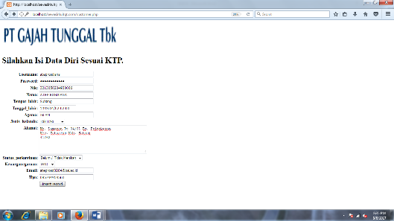

Lampiran B.3. Tampilan Menu Berhasil Daftar
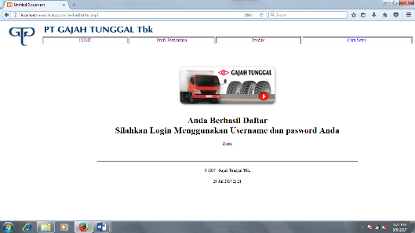

Lampiran B.4. Tampilan Menu login
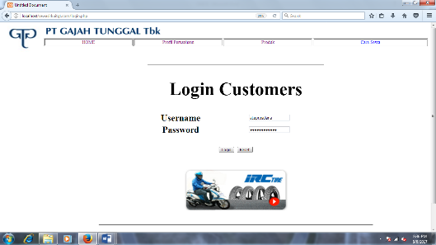

Lampiran B.5. Tampilan Menu Berhasil
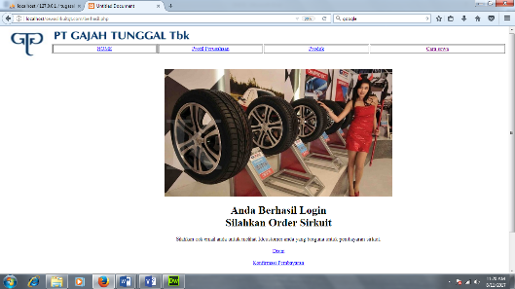

Lampiran B.6. Tampilan Menu PGJO
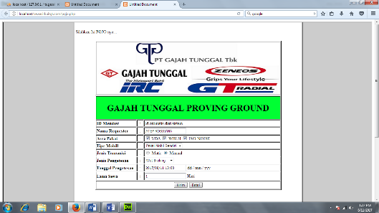

Lampiran B.7. Tampilan Menu PGJO
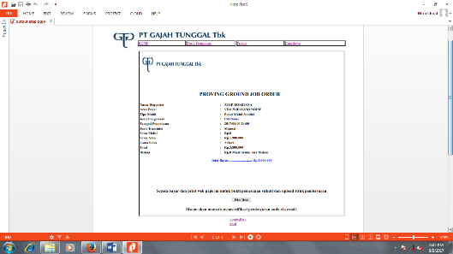

Lampiran B.8. Tampilan Menu Pembayaran
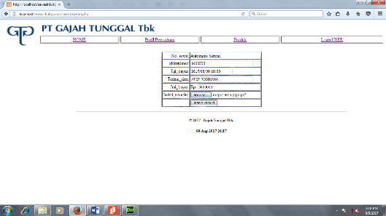

Lampiran B.9. Tampilan Konfirmasi Pembayaran
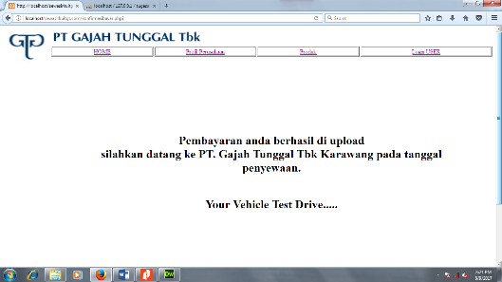

Lampiran B.10. Tampilan Info Saham
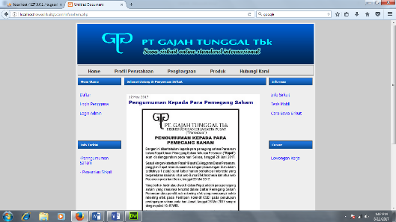

Lampiran B.11. Tampilan Peresmian Sirkuit
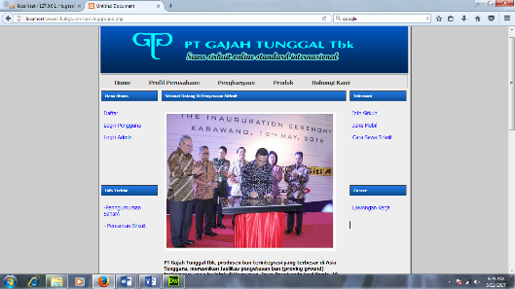

Lampiran B.12. Tampilan Info Sirkuit
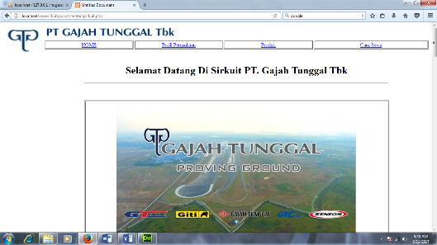

Lampiran B.13. Tampilan Jenis Mobil
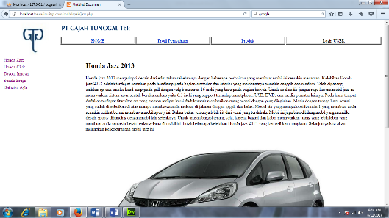

Lampiran B.14. Tampilan Cara Sewa Sirkuit
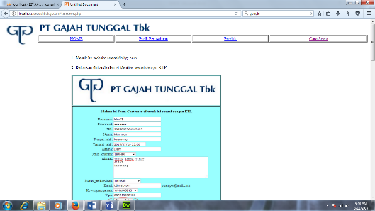

Lampiran B.15. Tampilan Lowongan Kerja


Lampiran B.16. Tampilan Login Admin
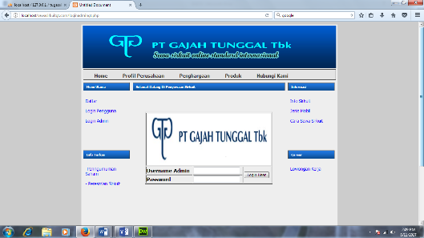

Lampiran B.17. Tampilan Home User
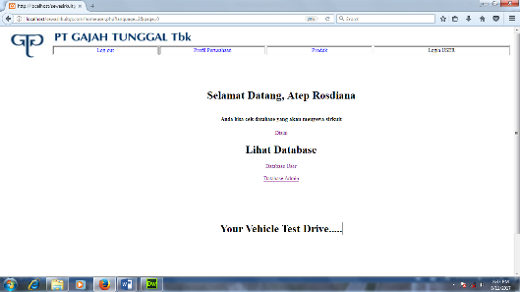

Lampiran B.18. Tampilan Database Sewa
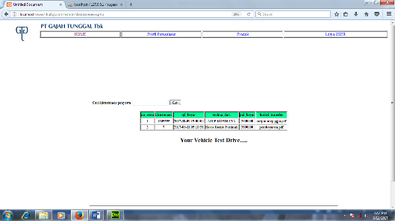

Lampiran B.19. Tampilan Database Customer
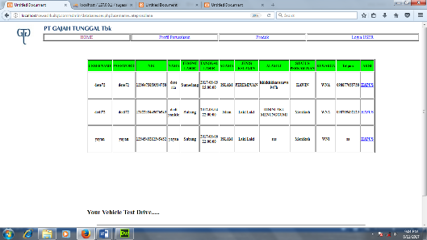

Lampiran B.20. Tampilan Database Admin
