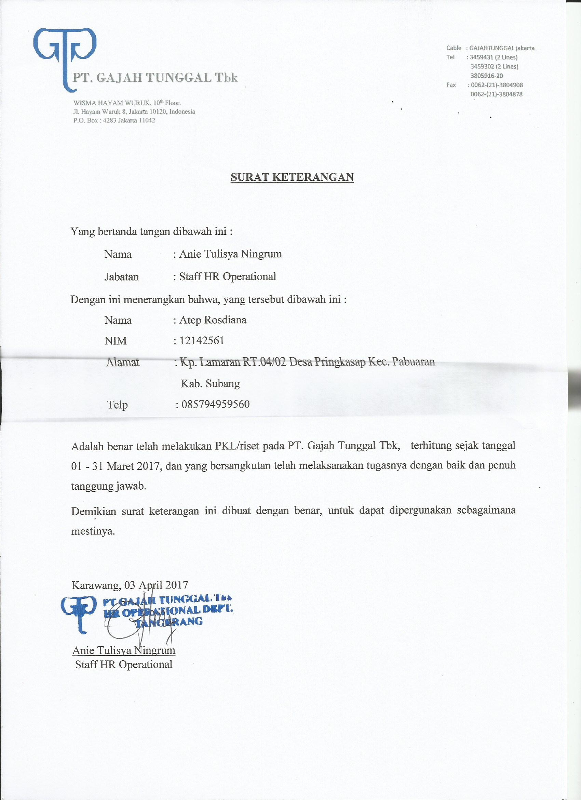
LAMPIRAN-LAMPIRAN
Lampiran A.1. Surat Keterangan Riset (PKL)

